

INTERNATIONAL SCHOOL OF MANAGEMENT & TECHNOLOGY

**ASSIGNMENT COVER SHEET**

|  |  |  |  |
| --- | --- | --- | --- |
| STUDENT DETAILS | | | |
|  | | | |
| Student ID |  | **Reg No.** |  |
| Family Name | Shrestha | **Given Name** | Bisesh |
| Enrolment Year | 2019 | **Section** | N4 |
| Semester | 4th | **Email** | bisesh@ismt.edu.np |

|  |  |  |  |  |
| --- | --- | --- | --- | --- |
| UNIT DETAILS | | | | |
| Unit Title | Cloud Computing | **Unit Code** | F/615/1644 | |
| Assessor Name | **Suman Koirala** | **Issued Date** | 07/11/2021 | |
| Assignment Title | **Prime Bank Ltd.** | | | |
| Assignment No | **1/1** | **Submission Date** | | 09/10/2021 |
| Qualification | BTEC HND IN COMPUTING | **Campus** | | **ISMT** |





**STUDENT ASSESSMENT SUBMISSION AND DECLARATION**

When submitting evidence for assessment, each student must sign a declaration confirming that the work is their own.

|  |  |  |  |
| --- | --- | --- | --- |
| Student Name | Bisesh Shrestha | Assessor Name | Suman Koirala |
| Issue Date | 07/11/2021 | Submission Date | 09/10/2021 |
| Programme | Networking | | |
| Unit Name | Cloud Computing | | |
| Assignment Title | Prime Bank Ltd. | | |

**Plagiarism**

Plagiarism is a particular form of cheating. Plagiarism must be avoided at all costs and students who break the rules, however innocently, may be penalized. It is your responsibility to ensure that you understand correct referencing practices. As a university level student, you are expected to use appropriate references throughout and keep carefully detailed notes of all your sources of materials for material you have used in your work, including any material downloaded from the Internet. Please consult the relevant unit lecturer or your course tutor if you need any further advice.

**Student Declaration**

I certify that the assignment submission is entirely my own work and I fully understand the consequences of plagiarism. I understand that making a false declaration is a form of malpractice.



Pearson Education 2018  
Higher Education Qualifications

Contents

Part 1 5

Scenario brief 5

Introduction 8

P1 Analyze the evolution and fundamental concepts of Cloud Computing. 8

Cloud computing 8

History of evolution of cloud computing: 9

Importance of cloud computing: 10

Benefits of cloud computing 10

P2 Design an appropriate architectural Cloud Computing framework for a given scenario. 11

Architecture of cloud services: 11

Components of Cloud Computing Architecture 12

IaaS: 13

Advantages of IaaS 13

PaaS 14

Advantages of PaaS 15

Serverless computing 15

Advantage of serverless computing 16

Saas 16

Advantages of SaaS 17

P3 Define an appropriate deployment model for a given scenario. 17

Deployment of model 17

Hybrid cloud 17

Advantages of the hybrid cloud: 18

Disadvantages of hybrid cloud: 18

Public clouds 18

Advantages of public clouds: 18

Disadvantages of a public cloud 19

Private cloud 19

Advantages of a private cloud: 19

Disadvantages of private cloud: 19

Selecting the Deployment Model for given scenario: 19

P4 Compare the service models for choosing an adequate model for a given scenario. 21

Conclusion: 24

Part 2 24

Introduction 24

P5 Configure a Cloud Computing platform with a cloud service provider’s framework. 25

Configuration of cloud computing: 26

Use of cloud marketplace to deploy LAMP stack: 27

Creating of virtual machine using GCP console and command line: 28

Creating of cloud storage bucket using the gsutil command line: 31

Creating of cloud SQL instance: 32

Starting of Kubernetes Engine cluster: 32

Staring app engine: 35

P6 Implement a cloud platform using open source tools. 37

Installing packages: 37

Creating of inventory: 38

Minimal installation: 38

Customization: 39

MidoNet NSDB: 40

Use of Ceph: 41

Using MinIO: 41

Enabling the Certbot integration: 42

Connectivity testing: 42

Installation performing: 42

Deploying Network Monitoring Tool: Nagios XI 43

Configuring AI Chatbot for customer support and review: 46

Create a Dialog flow agent 46

Create Intents 48

Allow Fulfillment to Store Help Ticket Data 51

Verify that Tickets Are Logged in Data store. 54

Conclusion 55

Part3 55

ARTICLE 57

Common Challenges and security issues in Cloud Computing and their solution 57

P7: Analyse the most common problems which arise in a Cloud Computing platform and discuss appropriate solutions to these problems. 57

P8:Assess the most common security issues in cloud environments. 60

Common security issues in cloud computing platform: 60

Presentation slide on the topic given to me: 62

References 68

# Part 1

**With reference to the scenario, prepare a report which:**

* **Analyzes** the evolution and fundamental concept of cloud computing.
* Presents design of an appropriate architectural Cloud Computing framework.
* **Define** an appropriate deployment model and **compares** the service models for choosing a model with real world examples.

# Scenario brief

I am responsible for all elements of this cloud deployment as a Network and System Administrator of prime bank which is one of the leading banks in the country that runs a number of financial services. Recently Prime bank has decided to maintain private data center in Bhairawa for its mission critical and confidential data. The data center is to maintain with high security and resiliency. I am in charge of researching the available cloud platforms and selecting the finest one from among them. Create, develop, and configure a platform for use in banking operations.

In this part, I'll show that I understanding the fundamentals of cloud computing and how it works. It covers the fundamentals of cloud computing, its principles, the cloud ecosystem, cloud architecture, network connection in cloud computing, cloud management, and cloud application migration. In addition, one of my responsibilities is to research the evolution and core concept of cloud computing. In addition, I'll be creating an architectural cloud computing framework for a given scenario. This section will also cover deployment models like private cloud, public cloud, hybrid cloud, and community cloud, as well as service models like SaaS, PaaS, AaaS, and IaaS. In addition, I will evaluate technological drivers such as cloud software process models, virtualization, and so on.

**Report on:**

**Fundamental and architecture of cloud computing and the deployment models, service models and technological driver of cloud computing**

**Bisesh Shrestha**

**Contents:**

* **Introduction**
* **History of development of cloud computing**
* **Importance of cloud computing**
* **Selection of cloud service provider**
* **Types of cloud service model**
* **Types of cloud deployment model**

# Introduction

This section contains information on the principles and architecture of cloud computing in a succinct manner. The nature of cloud computing, and how we got to the cloud, is the first item that has to be addressed. The basic architecture of the cloud computing platform is built, as well as the requirement and purpose for the organization to shift to the cloud. Other fundamental elements are compared to simple assumptions such as deployment models and service model models. In addition, it gives an overview of cloud computing technological drivers and how those drivers improve the cloud computing paradigm. Finally, the logic behind the Cloud Computing resources that are used to support diverse cloud operations.

# P1 Analyze the evolution and fundamental concepts of Cloud Computing.

# Cloud computing

The delivery of various services through the Internet is known as cloud computing. These resources include data storage, servers, databases, networking, and software, among other tools and applications. Cloud-based storage allows you to store files to a distant database rather than maintaining them on a proprietary hard drive or local storage device. As long as an electronic device has internet connectivity, it has access to the data as well as the software applications needed to run it. For a variety of reasons, including cost savings, greater productivity, speed and efficiency, performance, and security, cloud computing is a popular choice among individuals and corporations.

Cloud computing is named as such because the information being accessed is found remotely in the cloud or a virtual space. Cloud service providers allow customers to store files and apps on remote servers and then access the information through the Internet. This means that the user does not need to be at a certain location to access it, allowing them to work from anywhere. Cloud computing offloads all of the hard labor associated with crunching and processing data from the device you carry or sit at. It also offloads all of that work to massive computer clusters located thousands of miles distant in cyberspace. The Internet becomes the cloud, allowing you to access your data, work, and apps from any device that can connect to the Internet, wherever in the globe. Cloud computing is available in both public and private versions. For a price, public cloud providers offer their services through the Internet. Private cloud services, on the other hand, cater to a limited number of customers. These services are a network system that provides hosted services. There is also a hybrid option, which combines elements of both the public and private services.

## History of evolution of cloud computing:

Cloud computing is a type of computing in which services such as storage, infrastructure, and applications are accessed by paying for remote access to another company's services. When the mainframe computer was in operation in the 1950s, the blueprints for cloud computing were apparent since many users reached the central computer through fake terminals. Various firms came up with the notion of providing shared access to a single computer to save money. The earliest notions of time-sharing were popularized in the 1960s through RJE (Remote Job Entry), a name that was largely associated with big companies like IBM and DEC. By the early 1970s, full-time-sharing solutions were available on systems including Multics, Cambridge CTSS, and the earliest UNIX ports.

Telecommunications companies started offering virtual private network (VPN) services with equivalent quality of service but at a cheaper cost in the 1990s, replacing dedicated point-to-point data connections. They might make better use of total network capacity by moving traffic as needed to balance server use. They started using the cloud symbol to mark the boundary between what the provider was responsible for and what the users were responsible for. This border was extended by cloud computing to include all servers as well as network equipment. Scientists and technologists investigated ways to make large-scale computing power available to more people through time-sharing as computers grew more widely distributed. They worked with algorithms to prioritize CPUs and boost efficiency for end users by optimizing the infrastructure, platform, and apps. After decades, Amazon Web Services (AWS) and the service Elastic Cloud Compute (EC2) were launched, allowing businesses to rent virtual machines from which to run their own programs and applications. In the same year, Google released Google Docs, which allows users to create, edit, and modify documents, as well as share them across the cloud.

The cloud metaphor for virtualized services may be traced back to General Magic in 1994, when it was used to depict the universe of "places" that a mobile agent might visit in the Tele script environment. "The beauty of Tele script," Andy Herzfeld explains, "is that today, instead of just having a device to program, we have the entire Cloud out there, where a single program can go and go to many different sources of information and build a type of virtual service." In 2007, a collaborative effort between multiple colleges, IBM, and Google worked to establish a server farm for research purposes.

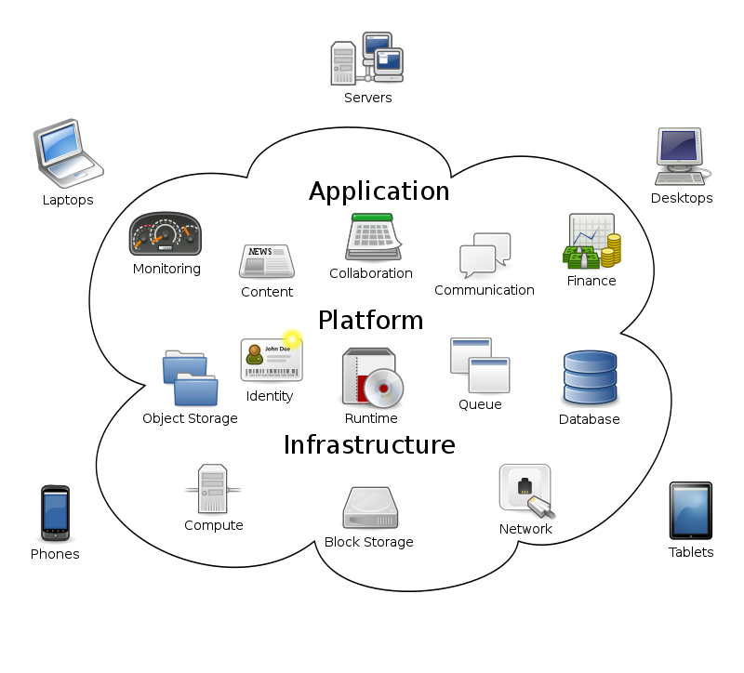

## Importance of cloud computing:

Cloud computing has many importance which may be either for organization, business, or individuals. Some of the common importance of cloud computing are given below:

* It enables us to run software programs without installing them on our computers.
* It enables us to store and access our multimedia content via the internet.
* It enables us to develop and test programs without necessarily having servers.
* It allows users to access all of the features and files of the system without having to keep the bulk of that system on their own computers.
* It offers remote access to any work-related data

## Benefits of cloud computing

Cloud computing is a big shift from the traditional way businesses think about IT resources. Here are seven common reasons organizations are turning to cloud computing services:

**Cost:**

Cloud computing eliminates the capital expense of buying hardware and software and setting up and running on-site datacenters the racks of servers, the round-the-clock electricity for power and cooling, and the IT experts for managing the infrastructure. It adds up fast.

**Speed:**

Most cloud computing services are provided self service and on demand, so even vast amounts of computing resources can be provisioned in minutes, typically with just a few mouse clicks, giving businesses a lot of flexibility and taking the pressure off capacity planning.

**Global** **scale:**

The benefits of cloud computing services include the ability to scale elastically. In cloud speak, that means delivering the right amount of IT resources. for example, more or less computing power, storage, bandwidth—right when they’re needed, and from the right geographic location.

**Productivity:**

On-site datacenters typically require a lot of “racking and stacking” hardware setup, software patching, and other time-consuming IT management chores. Cloud computing removes the need for many of these tasks, so IT teams can spend time on achieving more important business goals.

**Performance:**

The biggest cloud computing services run on a worldwide network of secure datacenters, which are regularly upgraded to the latest generation of fast and efficient computing hardware. This offers several benefits over a single corporate datacenter, including reduced network latency for applications and greater economies of scale.

**Reliability:**

Cloud computing makes data backup, disaster recovery, and business continuity easier and less expensive because data can be mirrored at multiple redundant sites on the cloud provider’s network.

**Security:**

Many cloud providers offer a broad set of policies, technologies, and controls that strengthen your security posture overall, helping protect your data, apps, and infrastructure from potential threats.

# P2 Design an appropriate architectural Cloud Computing framework for a given scenario.

## Architecture of cloud services:

Most cloud computing services fall into four broad categories: infrastructure as a service (IaaS), platform as a service (PaaS), serverless, and software as a service (SaaS). These are sometimes called the cloud computing "stack" because they build on top of one another. Knowing what they are and how they’re different makes it easier to accomplish your business goals.

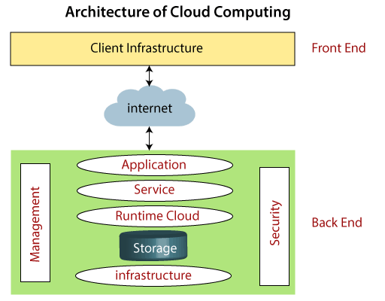

**Front End**

The front end is used by the client. It contains client-side interfaces and applications that are required to access the cloud computing platforms. The front end includes web servers (including Chrome, Firefox, internet explorer, etc.), thin & fat clients, tablets, and mobile devices.

**Back End**

The back end is used by the service provider. It manages all the resources that are required to provide cloud computing services. It includes a huge amount of data storage, security mechanism, virtual machines, deploying models, servers, traffic control mechanisms, etc.

## Components of Cloud Computing Architecture

There are the following components of cloud computing architecture -

1. **Client Infrastructure**

Client Infrastructure is a Front end component. It provides GUI (Graphical User Interface) to interact with the cloud.

2. **Application**

The application may be any software or platform that a client wants to access.

3. **Service**

A Cloud Services manages that which type of service you access according to the client’s requirement. Cloud computing offers the following three type of services:

### IaaS:

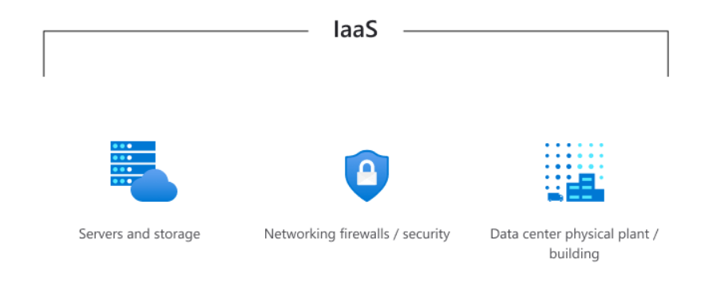

Infrastructure as a service (IaaS) is a pay-as-you-go cloud computing service that provides critical computation, storage, and networking resources on demand. Along with software as a service (SaaS), platform as a service (PaaS), and serverless, IaaS is one of the four categories of cloud services. Migrating your infrastructure to an IaaS service allows you to decrease on-premises data center maintenance, save money on hardware, and obtain real-time business analytics. IaaS solutions allow you to scale your IT resources up and down in response to demand. They also aid in the rapid deployment of new apps and the enhancement of the dependability of your underlying infrastructure.

## Advantages of IaaS

* **Reduces capital expenditures and optimizes costs:**

IaaS eliminates the cost of configuring and managing a physical datacenter, which makes it a cost-effective choice for migrating to the cloud. The pay-as-you-go subscription models used by IaaS providers help you reduce hardware costs and maintenance and enable your IT team to focus on core business.

* **Increases scale and performance of IT workloads:**

IaaS lets you scale globally and accommodate spikes in resource demand. That way, you can deliver IT resources to employees from anywhere in the world faster and enhance application performance.

* **Increases stability, reliability, and supportability**

With IaaS, there's no need to maintain and upgrade software and hardware or troubleshoot equipment problems. With the appropriate agreement in place, the service provider assures that your infrastructure is reliable and meets service-level agreements (SLAs).

* **Improves business continuity and disaster recovery**

Achieving high availability, business continuity, and disaster recovery is expensive because it requires a significant amount of technology and staff. But with the right SLA in place, IaaS helps to reduce this cost. It also helps you access applications and data as usual during a disaster or outage.

* **Enhances security**

With the appropriate service agreement, a cloud service provider can offer better security for your applications and data than the security you would attain in house.

* **Helps you innovate and get new apps to users faster**

With IaaS, once you've decided to launch a new product or initiative, the necessary computing infrastructure can be ready in minutes or hours, rather than in days or weeks. And because you don't need to set up the underlying infrastructure, IaaS lets you deliver your apps to users faster.

### PaaS

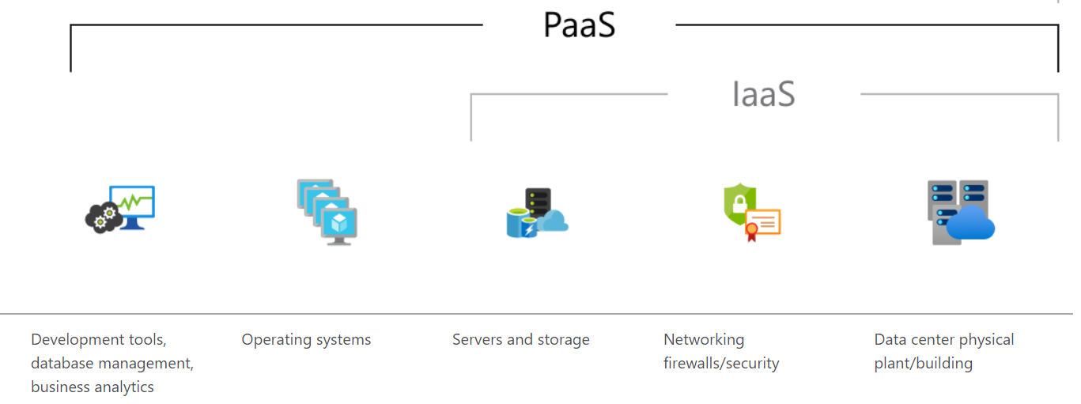

It is a full cloud development and deployment environment with resources that enable you to produce everything from simple cloud-based apps to sophisticated, cloud-enabled business systems. You pay as you go for the resources you need from a cloud service provider and access them over a secure Internet connection. PaaS, like IaaS, contains infrastructure servers, storage, and networking as well as middleware, development tools, BI services, database management systems, and other services. PaaS is intended to support the whole web application lifecycle, including development, testing, deployment, management, and update. You may avoid the cost and complexity of purchasing and managing software licenses, underlying application infrastructure and middleware, container orchestrators like Kubernetes, as well as development tools and other resources by using PaaS.

## Advantages of PaaS

By delivering infrastructure as a service, PaaS offers the same advantages as IaaS. But its additional features—middleware, development tools, and other business tools give you more advantages:

* **Cut coding time**: PaaS development tools can cut the time it takes to code new apps with pre-coded application components built into the platform, such as workflow, directory services, security features, search, and so on.
* **Add development capabilities without adding staff**: Platform as a Service components can give your development team new capabilities without your needing to add staff having the required skills.
* **Develop for multiple platforms including mobile more easily:** Some service providers give you development options for multiple platforms, such as computers, mobile devices, and browsers making cross-platform apps quicker and easier to develop.
* **Use sophisticated tools affordably**: A pay-as-you-go model makes it possible for individuals or organizations to use sophisticated development software and business intelligence and analytics tools that they could not afford to purchase outright.
* **Support geographically distributed development teams:** Because the development environment is accessed over the Internet, development teams can work together on projects even when team members are in remote locations.
* **Efficiently manage the application lifecycle**: PaaS provides all of the capabilities that you need to support the complete web application lifecycle: building, testing, deploying, managing, and updating within the same integrated environment.

### Serverless computing

By removing the requirement for developers to manage infrastructure, serverless computing allows them to design apps quicker. The infrastructure necessary to run the code is automatically provisioned, scaled, and managed by the cloud service provider with serverless apps. It's vital to remember that servers are still running the code while understanding the notion of serverless computing. The moniker "serverless" stems from the notion that infrastructure provisioning and administration duties are hidden from the developer. This technique allows developers to focus more on the business logic and provide greater value to the firm's core. Serverless computing aids teams in increasing productivity and bringing products to market faster, as well as allowing enterprises to better allocate resources and remain focused on innovation.

## Advantage of serverless computing

**No infrastructure management:** Using fully managed services enables developers to avoid administrative tasks and focus on core business logic. With a serverless platform, you simply deploy your code, and it runs with high availability.

**Dynamic scalability:** With serverless computing, the infrastructure dynamically scales up and down within seconds to match the demands of any workload.

**Faster time to market:** Serverless applications reduce the operations dependencies on each development cycle, increasing development teams’ agility to deliver more functionality in less time.

**More efficient use of resources:** Shifting to serverless technologies helps organizations reduce TCO and reallocate resources to accelerate the pace of innovation.

### Saas

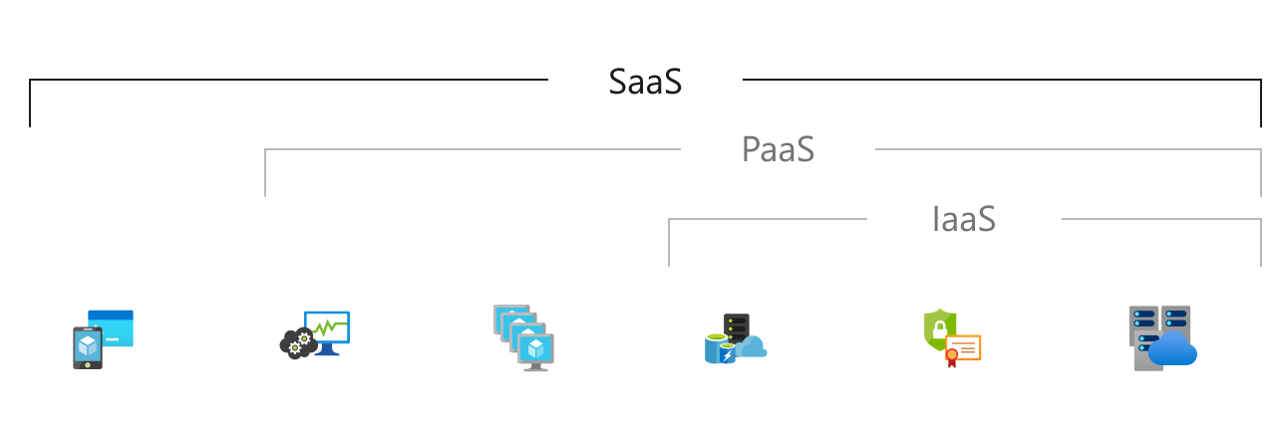

Software as a service (SaaS) allows users to connect to and use cloud-based apps over the Internet. Common examples are email, calendaring, and office tools (such as Microsoft Office 365). SaaS provides a complete software solution that you purchase on a pay-as-you-go basis from a cloud service provider. You rent the use of an app for your organization, and your users connect to it over the Internet, usually with a web browser. All of the underlying infrastructure, middleware, app software, and app data are located in the service provider’s data center. The service provider manages the hardware and software, and with the appropriate service agreement, will ensure the availability and the security of the app and your data as well. SaaS allows your organization to get quickly up and running with an app at minimal upfront cost.

## Advantages of SaaS

**Gain access to sophisticated applications**: To provide SaaS apps to users, you don’t need to purchase, install, update, or maintain any hardware, middleware, or software. SaaS makes even sophisticated enterprise applications, such as ERP and CRM, affordable for organizations that lack the resources to buy, deploy, and manage the required infrastructure and software themselves.

**Pay only for what you use**: You also save money because the SaaS service automatically scales up and down according to the level of usage.

**Use free client software**: Users can run most SaaS apps directly from their web browser without needing to download and install any software, although some apps require plugins. This means that you don’t need to purchase and install special software for your users.

**Mobilize your workforce easily**: SaaS makes it easy to “mobilize” your workforce because users can access SaaS apps and data from any Internet-connected computer or mobile device. You don’t need to worry about developing apps to run on different types of computers and devices because the service provider has already done so. In addition, you don’t need to bring special expertise onboard to manage the security issues inherent in mobile computing. A carefully chosen service provider will ensure the security of your data, regardless of the type of device consuming it.

**Access app data from anywhere**: With data stored in the cloud, users can access their information from any Internet-connected computer or mobile device. And when app data is stored in the cloud, no data is lost if a user’s computer or device fails.

# P3 Define an appropriate deployment model for a given scenario.

## Deployment of model

Not all clouds are the same and not one type of cloud computing is right for everyone. Several different models, types, and services have evolved to help offer the right solution for your needs.

First, you need to determine the type of cloud deployment, or cloud computing architecture, that your cloud services will be implemented on. There are three different ways to deploy cloud services: on a public cloud, private cloud, or hybrid cloud.

## Hybrid cloud

A hybrid cloud mixes on-premises technology (or a private cloud) with a public cloud. Data and programs may travel between the two environments thanks to hybrid clouds. Due to business imperatives such as satisfying regulatory and data sovereignty requirements, maximizing on-premises technology investment, or solving low latency challenges, many enterprises opt for a hybrid cloud solution. Edge workloads are becoming a part of the hybrid cloud. Edge computing offers cloud computing capability to IoT devices, bringing data closer to the source. Devices spend less time connecting with the cloud as a result of relocating workloads to the edge, resulting in lower latency and the ability to function reliably over lengthy periods of downtime.

### Advantages of the hybrid cloud:

* **Control**: your organization can maintain a private infrastructure for sensitive assets or workloads that require low latency.
* **Flexibility**: you can take advantage of additional resources in the public cloud when you need them.
* **Cost**-**effectiveness**: with the ability to scale to the public cloud, you pay for extra computing power only when needed.
* **Ease**: transitioning to the cloud doesn’t have to be overwhelming because you can migrate gradually—phasing in workloads over time.

### Disadvantages of hybrid cloud:

* communication occurs between public and private clouds; it can become conflicted at times

## Public clouds

The most common type of cloud computing deployment is public clouds. A third-party cloud service provider owns and operates the cloud resources (such as servers and storage), which are distributed through the internet. The cloud provider owns and manages the hardware, software, and other supporting infrastructure in a public cloud. A public cloud, such as Microsoft Azure, is one example.

In a public cloud, you and other companies or cloud "tenants" share the same infrastructure, storage, and network devices, and you use a web browser to access services and manage your account. Web-based email, online office programs, storage, and testing and development environments are all common uses for public cloud installations.

### Advantages of public clouds:

* **Lower costs**: no need to purchase hardware or software, and you pay only for the service you use.
* **No maintenance**: your service provider provides the maintenance.
* **Near-unlimited scalability**: on-demand resources are available to meet your business needs.
* **High reliability**: a vast network of servers ensures against failure.

### Disadvantages of a public cloud

* Offer less customization
* Server are shared so it is less secure
* Sudden changes by cloud provider can have negative consequences

## Private cloud

A private cloud is made up of cloud computing resources that are only used by one company or organization. The private cloud can be physically installed on-site at your company's datacenter or hosted by a third-party service provider. In a private cloud, however, the services and infrastructure are always kept on a private network, and the hardware and software are devoted entirely to your company. A private cloud can help a business modify its resources to fulfill unique IT requirements in this way. Government agencies, financial institutions, and other mid- to large-sized companies with mission-critical activities that want more control over their environment frequently employ private clouds.

### Advantages of a private cloud:

* **More flexibility**: your organization can customize its cloud environment to meet specific business needs.
* **More control**: resources are not shared with others, so higher levels of control and privacy are possible.
* **More scalability**: private clouds often offer more scalability compared to on-premises infrastructure.

### Disadvantages of private cloud:

* Requires extensive expertise of IT personnel
* Comparatively expensive
* More difficult to access data from remote locations.

## Selecting the Deployment Model for given scenario:

We must use a separate cloud computing service model based on the performing action in the company in the provided scenario. Depending on the demands of the company, we must employ IaaS, PaaS, or SaaS in the organization. Each service model has its own set of features and attributes. We've previously discussed the cloud computing service model and its characteristics so that we can easily select the ideal service model for our firm based on our needs and requirements.

Prime bank is converting its system to cloud computing in this case, thus we'll need to deploy multiple service models depending on the bank's demands and requirements. We have created a hybrid cloud model in the prime bank, which allows us to use both the public and private cloud, in response to the prime bank's requirements. In the bank, we have a service that we need to execute both in the public and private clouds. We've kept the IaaS and PaaS services in the private cloud because we're using the hybrid cloud.

As previously said, I have utilized the hybrid cloud, and this report will analyze and evaluate why I picked it over others. We may have characteristics from both public and private cloud development approaches in a hybrid cloud. For better work and contact with clients, we need both public and private clouds, according to the scenario.

The following are the reasons why I picked the hybrid cloud:

**Cloud bursting**: It is an application deployment technique in which a program operating on a private cloud can burst onto a public cloud when it requires additional computing resources. Because enterprises don't have to worry as much about the security of the data being transported to the public cloud, cloud bursting is suitable for apps that handle non-sensitive data. It's a cost-effective technique in which a company just pays for extra computer resources when they're needed.

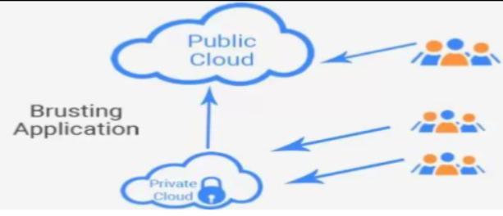

**Better flexibility and agility:** The hybrid cloud allows organizations to be more flexible and agile by facilitating interoperability across on-premises data centers, private clouds, and public clouds. It also assists organizations in efficiently harmonizing their information and resources. The hybrid cloud gives users total control over their system, security, and rules, allowing them to access resources from anywhere on the internet at any time.

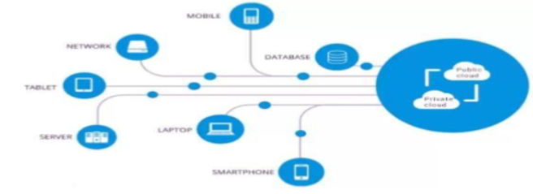

**Scalability:** Scaling up or down an organization's existing on premises IT infrastructure for rapid expansion can be inefficient and costly today. Hybrid cloud allows such businesses to connect their existing infrastructure to a specific cloud approach that is needed at the moment. It gives a company limitless cloud storage that they can utilize as required. As a consequence, the hybrid cloud model offers enterprises throughout the sector on-time, cost-effective, and efficient scalability choices.

**Enhanced security**: Security is one of the most critical elements affecting cloud adoption. Organizations can employ dedicated infrastructure for storing and accessing key computer resources while using the public cloud as expanded storage for less critical assets, making a hybrid cloud solution more secure than a public cloud. Cloud service providers by default support dedicated on-premise servers. This allows businesses to safely connect between public and private clouds over a private network.

**Reduced costs:**

Cost is a key factor for many organizations considering migrating to the cloud. A hybrid cloud is a great option for companies that want more security and control of their data but need a cost-effective way to scale their operations to meet spikes in demand (as well as long-term growth). Organizations can use the hybrid cloud option to keep their core, business-critical, and sensitive data on their own private servers while offloading fewer sensitive data and applications to the public when demand spikes, organizations that use a hybrid cloud option can avoid large capital expenditures to expand their infrastructure by paying only for the cloud resources they use.

# P4 Compare the service models for choosing an adequate model for a given scenario.

|  |  |  |  |
| --- | --- | --- | --- |
|  | IaaS | PaaS | SaaS |
| Full Form | Infrastructure as a  Service | Platform as a Service | Software as a Service |
| Level | Basic layer of computing | Top of IaaS. | Complete pack of all service. |
| Characteristics | Usually platform-  Independent; infrastructure costs are shared and thus reduced; service level agreement; pay by usages; self-scaling. | Consumes cloud infrastructure, caters to agile project management methods. | SLA, UI powered by  “Thin client” applications, cloud components, communication via APIs, stateless, lo0sely coupled, modular, sematic interoperability. |
| Offering | User gets the infrastructure and pays accordingly. Can install any OS, composition or software. | User gets what is demanded i.e.  Hardware, software, web environment, OS. Payment is made accordingly and user gets the platform to use. | User has nothing to worry about, a preconfigured package as per requirement is given and payed accordingly. |
| Feasibility | For people or companies not willing to invest too much on hardware. For those trying to do something temporarily. | All technical stack requirements met by the platform offering. | Used by a variety of users. Used over web on various location. |
| Technical understanding | In this model, we need to have more technical knowledge. | In this model, we just need to have the knowledge of the subject for the basic setup. | In this model, we do not need to have any technical knowledge. They are handled by the service provider. |
| Provider control | Server, storages, network, virtualization. | Servers, storages, networking, virtualization, OS, middleware, Runtime. | Servers, storages, networking, virtualization, OS, middleware, Runtime, application, data. |
| User controls | OS, middleware,  Runtime, application, data. | Application, data. | N/A |
| Deals with | Virtual machine storages, load balancer, network, server. | Runtimes, database and web servers. | Only application and web software. |
| Security | Should consider virtual and physical server’s security policy conformity. | Additional security is required to make sure rogue  applications don’t  exploit vulnerabilities in software platform. | Requires transparency in service provider’s security policies to be able to determine the degree of sensitive corporate data. |
| Advantages | * Spin up virtual machines * Install operating systems * Deploy middleware * Create storage buckets and backups for workload | * Lower software maintenance costs * Reduce coding time * Multiplatform development * Analytics and business intelligence * Micro services and APIs | * Zero installation and maintenance costs * Pay-per-use pricing Web accessibility * Enterprise-grade software * Remote access |
| Disadvantage | * Business efficiency and productivity largely depends on the vendor’s capabilities. * Potentially greater long-term costs | * Data security needs to be considered and scrutinized, as information is stored off-site. * Not every part of the company’s existing infrastructure may be built for the cloud | * Loss of control in terms of software applications * Limited range of applications * Connectivity requirement * Performance sometimes may get slower speech |
| Examples | Examples: G Suite: A product of Google, which is used to prepare document over the cloud. | AWS Elastic Beanstalk: It offers over 100 cloud computing services such as EC2, RDS, and S3. | AWS EC2: EC2 provides scalable infrastructure for companies who want to host cloud-based applications |

# Conclusion:

I was able to understand the fundamental concept of cloud computing and its progression in this part. Furthermore, I am aware of the various cloud deployment models (such as private cloud, public cloud, and hybrid cloud) as well as cloud services models (Infrastructure as a service, platform as a service, software as a service). In addition, I am able to collect data on the architectural cloud framework. Finally, for the creation of the cloud platform, I am capable of performing requirement analysis, feasibility studies, planning, designing, and other tasks.

# Part 2

**With reference to the scenario; develop cloud computing solutions:**

* **Configure a Cloud Computing** platform with a cloud service provider’s framework (AWS/GCP/Azure).
* **Implement** a cloud computing platform using open source tools.

# Introduction

I'm migrating on-premises data and applications to the cloud at prime bank. Ltd . In this case, I'm using a hybrid cloud, which combines public and private cloud resources. For the public cloud, I'm using Google Cloud Platform, and for the private cloud, I'm using Eucalyptus, an open source program. Google Cloud Platform is a collection of Google's computing, networking, storage, big data, machine learning, and management services that run on the same cloud infrastructure that Google uses internally for its end-user products like Google Search, Gmail, and Google Photos. The Google Cloud platform is a collection of cloud computing services that provide consumers access to Google's cloud computing system and other computer services. According to their needs, anyone can use the Google Cloud Platform. Aside from the many management tools accessible on Google Cloud Platform, the business has also integrated a number of cloud operations and features, including cloud storage, data analytics, developer choices, and sophisticated machine learning. Different aspects of the Google Cloud Platform are available, including Google Cloud App Engine, Google Cloud Container Engine, Google Cloud Storage, Google Big Query Service, and others.

I'm using Eucalyptus in my private cloud in a similar way. Eucalyptus is an open-source software framework that serves as a foundation for implementing private cloud computing on computer clusters. Eucalyptus uses infrastructure as a service (IaaS) to provide private and hybrid cloud systems. Eucalyptus is an Infrastructure as a Service (IaaS) solution that enables customers to provision computing and storage resources on demand. Eucalyptus is a platform that allows customers to calculate resources available in private clouds as well as resources available externally in public cloud services through a single interface. For Web services, it is built with an extensible and modular architecture.

In the prime bank , I am using cloud computing so here we could find the different technical and other challenges. Along with the advantages of the cloud platform, the other CSPs may encounter a number of obstacles as a result of their usage of cloud computing. Service availability, data confidentiality, auditability, security, and service provider transparency are some of the challenges

# P5 Configure a Cloud Computing platform with a cloud service provider’s framework.

In today's digital environment, the majority of businesses rely on cloud computing to conduct their operations successfully and efficiently. Similarly, at the Tri=Tech international Nepal, I have opted to employ the cloud service. There are a number of cloud service providers, including Google, AWS, Azure, IBM, and others. Each of them has its unique set of characteristics and capabilities for providing cloud computing services. I planned to utilize GCP as one of them (Google Cloud Platform). I will be able to meet the demands and requirements using GCP in the CSP. The following are some of the GCP features:

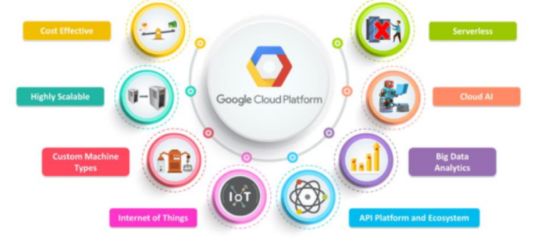

**Server less**: This is one of the new computing paradigms that abstract away the various complexities and difficulties that we face in managing servers for the mobile and API back ends, data processing, database and other.

**Big data:** The Google cloud platform has a complete big data solution, but there are two unique tools for big data processing and analysis. Big-Query allows users to run SQL. We can load bulk data directly from google cloud storage. Google cloud dataflow allows users to create, monitor and extract insights from a data processing pipeline.

**Integrations:** As we can have various types of APIs in the cloud, we can have the ability to have integrations. Not only this we can have the practice in the Internet of Things IoT and Cloud AI. This helps us in the making of the work efficient and effective in nature.

**Custom machines:** we can have custom machine types in GCP. We can customize them as per our needs and requirements of the organizations.

**Scalability:** In GCP, we can scale up and down the service as per our needs and requirements. Cost effective: Google recently shifted its pricing model to include sustained-use discounts and per-minute billing. The GCP is a pricing leader with high flexible pricing.

## Configuration of cloud computing:

I used Google Cloud Platform and completed the necessary configurations. The qwik labs were used for all of the configuration. I've also taken screenshots of all of the configurations.

## Use of cloud marketplace to deploy LAMP stack:

In this lab, we use the cloud marketplace to deploy the LAMP stack quickly and easily on the compute engine. The Bitnami LAMP stack provides a complete PHP, MYSQL and Apache development environment for Linux that can be launched in one click.

For the deployment of LAMP in the Google Cloud Platform, we follow the following steps:

* Here in the GCP console there on the navigation menu click on Market place.
* Type LAMP in the search.
* After that on the LAMP page click on the launch.
* Compute Engine API is initialized before.
* Then select the zone which is assigned by the qwik labs.
* We accept the GCP Marketplace terms of service.
* Clicking deploy.
* If we see the Welcome to Deployment Manager Message just click close.
* Then we can see the lampstack-1 has been deployed when it is fully deployed.

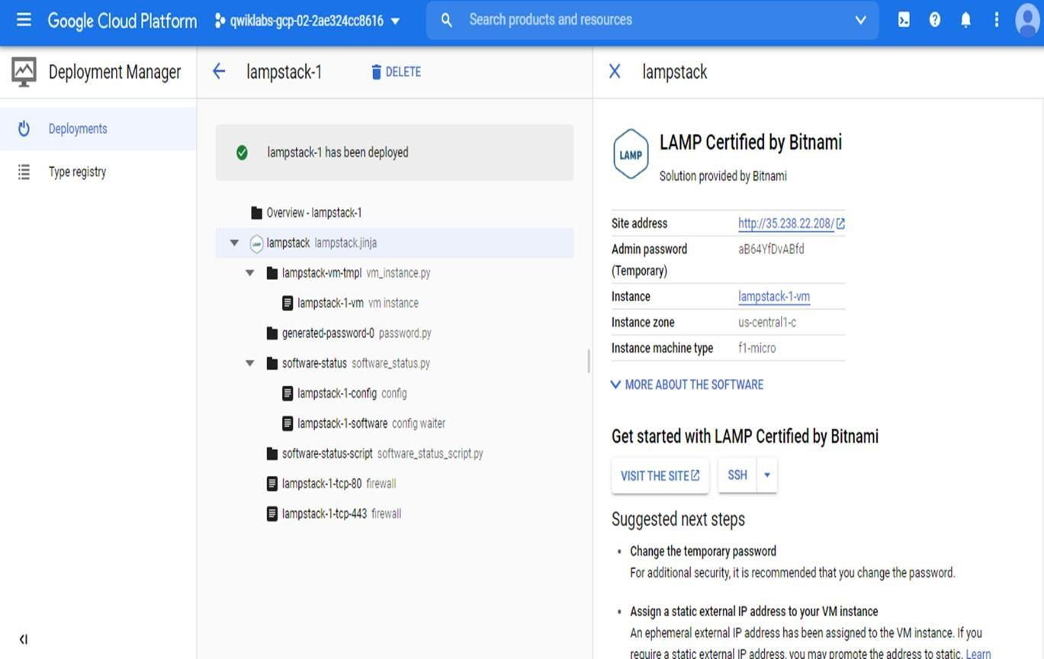

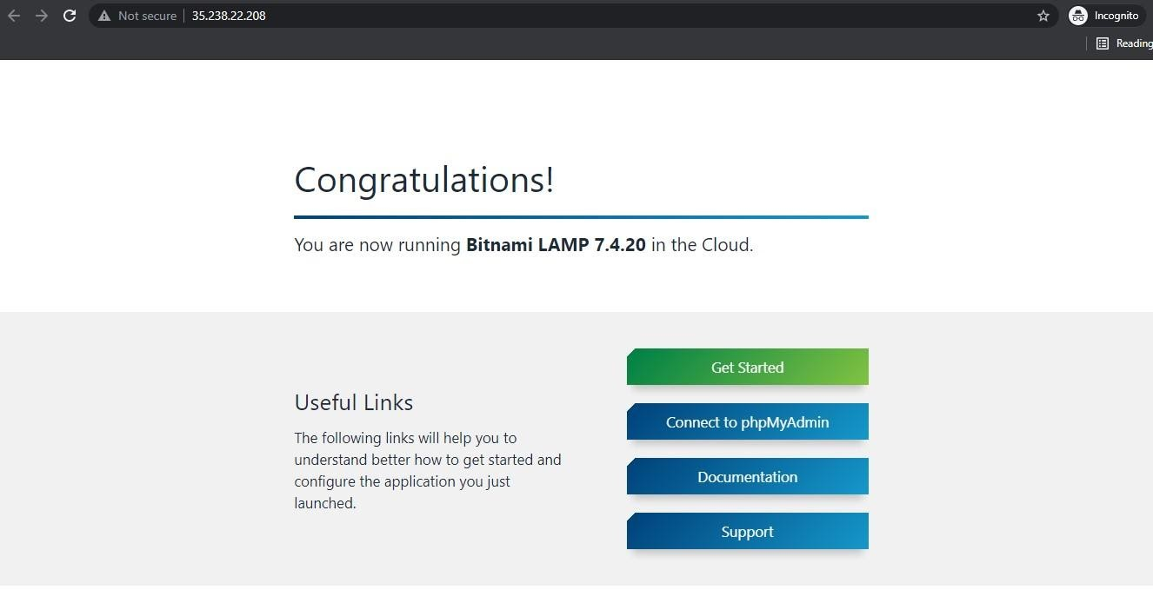

## Creating of virtual machine using GCP console and command line:

Here I am creating the VM instances by using GCP console and command line. Here are the steps and screenshots of the configuration.

1. In the Navigation menu click Compute Engine > VM instances.
2. Click create.
3. On the instance page, type Name i.e. my-vm-1.
4. In region and zone option, selecting the region and zone that is assigned by Qwik labs.
5. In machine type, accept the default.
6. In Boot disk option, select Debian GNU/Linux 10 (Buster).
7. Leave default for identity and API access.
8. For firewall, click allow HTTP traffic.
9. leave all other option default.

10. To create and launch the VM, click Create.

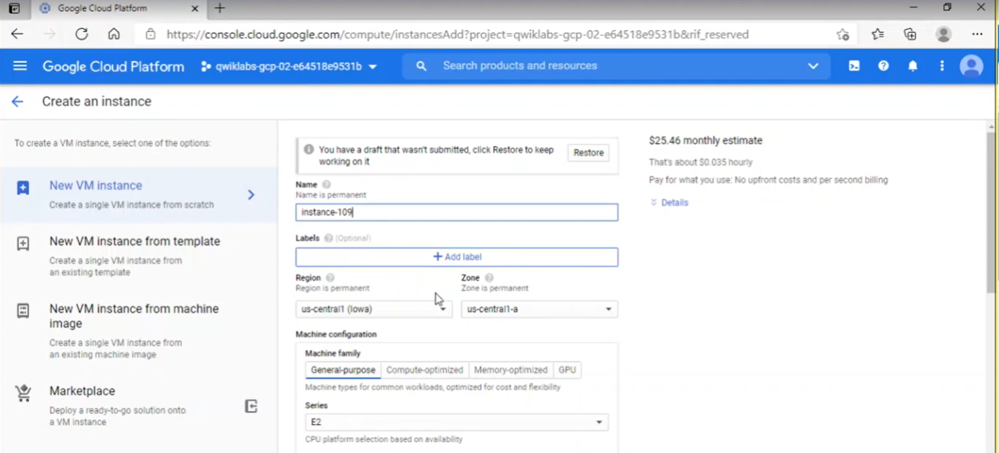

To make VM instances, using command line we follow the following steps:

1. In GCP console, on the top right toolbar, click the open cloud shell button.

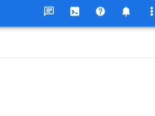

1. Click continue.

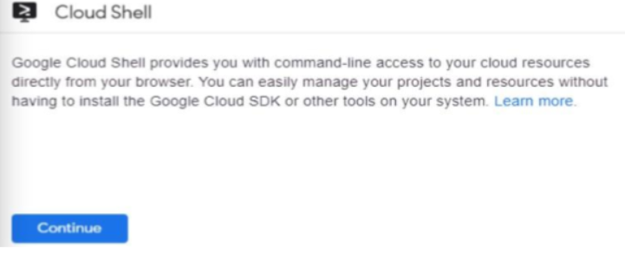

1. To set default zone, we enter this partial command line i.e. gcloud config set compute/zone followed by the zone we chose. As we can see it in below figure.

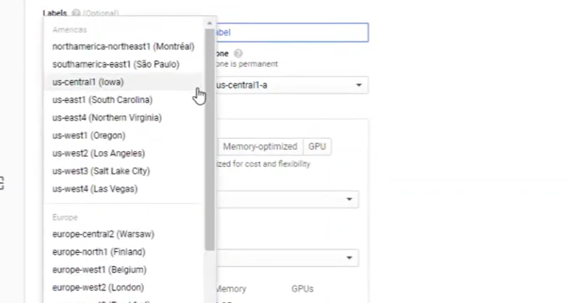

1. Now we create the instance using the command line i.e. gcloud instance create “instance_109”.
2. Finally, we can see the created virtual machine.

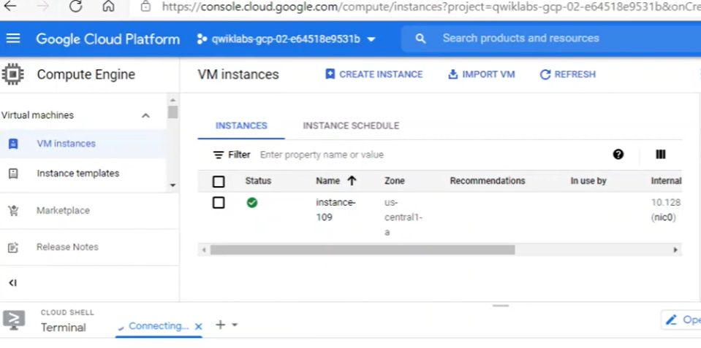

## Creating of cloud storage bucket using the gsutil command line:

The name of your cloud storage bucket must be unique globally. We utilize the same name as the cloud platform project ID, which is also globally unique, to ensure that the bucket name is unique.

Cloud storage buckets can be assigned to a single or many regions, such as the United States, Europe, or Asia. We associate bucket with the multi-region that is closest to the area and zone that Qwik labs or the teacher allocated to us in this activity. To create the cloud storage, I'm using the gsutil command line. The stages that we take are as follows:

1. Firstly, we need to open the terminal from the Google Cloud Platform.
2. Then we chose the location.
3. In the cloud shell, the DEVSHELL_PROJECT_ID environment variable contains project ID. Enter this command to make a bucket named after assigned project ID.



1. Then retrieve of the data from the publicly accessible cloud.
2. After that copy the file to the newly made bucket.





1. Now we can see the file bucket

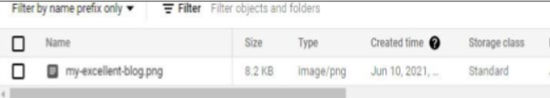

## Creating of cloud SQL instance:

Here I am creating the cloud SQL instance for the relational database. As blow figure, we can create SQL instance from GCP.

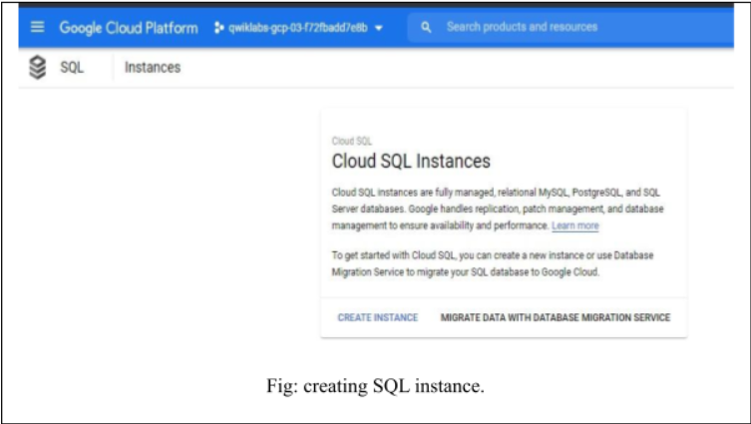

## Starting of Kubernetes Engine cluster:

To start the process of Kubernetes Engine cluster, we have to follow certain steps they are mention below:

After enabling API, we need to open the cloud shell and then follow the following steps:

1. We need to define the location using the command, export MY_ZONE = us-central1-a
2. Start managing kubernetes cluster by kubernetes Engine. Name the cluster webfrontend and configure it to run 2 nodes.
3. After creating cluster, we can check the version of kubernetes.



1. Now, we check the created Kubernetes cluster.

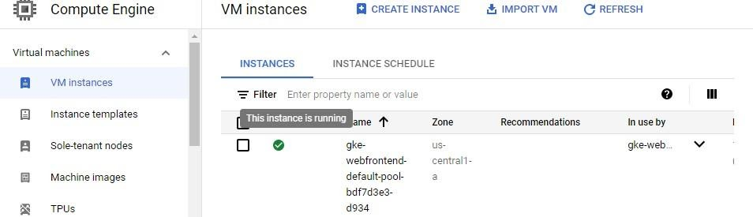

 Running and deploying of container:

For the running and deploying of the container, we need to follow the following steps:

* 1. From our cloud shell prompt, we launch a single instance of the nginx container.

https://lh5.googleusercontent.com/GGqvzsrA6xrsJ13d7Ai5O_yz2uIOY6e3px6ru9pUlWC68iMYJGEYVq4EXTnVLvk4olKPklOnI6dWeSjsvce6lLx6TUmCJ1KsO38kEKlqV14JGy70zT2q63nWNR2pkQ25ykPneHfJ

* 1. Viewing the pod that runs the nginx container.



* 1. Exposing the nginx container in the internet.

https://lh5.googleusercontent.com/ozz8JxogNPg75ag3p0hMZIQy7oMj7UbM5dcoa29iJjgr82VBT4wpfcMZSP6EjXoqVhFv03jDxyZQA9g2cd76asqLO2059U955JUhaeb-K23bRZ4gND49lYA9-noRSzovbedq35_7

* 1. Viewing the services.

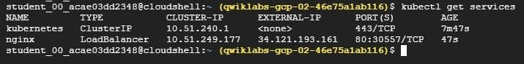

1. Scaling up the number of pods that are running on the service.



1. Confirming that it has updated number of pods.

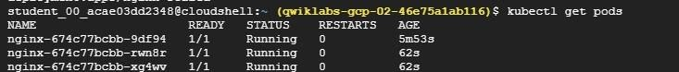

1. Checking it in the browser whether it is working or not using external IP address

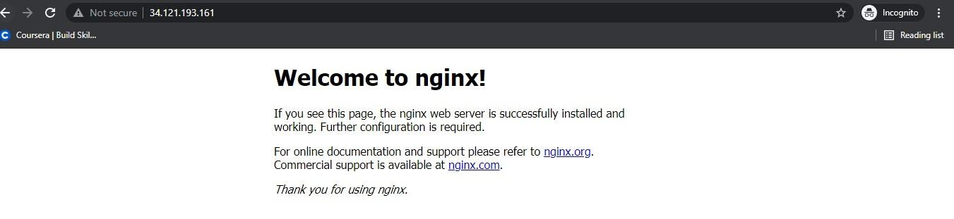

## Staring app engine:

For starting the app engine, we need to follow the following steps after opening the shell.

* 1. Initializing of the app engine and choosing the region.

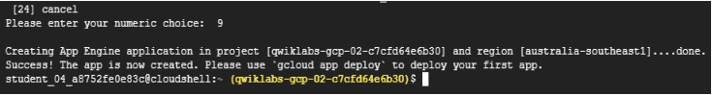

* 1. Cloning the source code repository for the sample application in the directory of help_world.

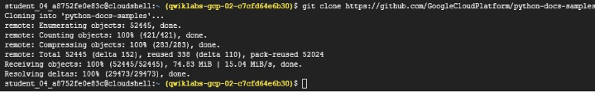

* 1. Now we find the source directory.

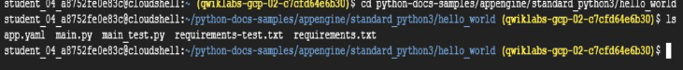

Now, for running Hello World app locally, we need to follow the following steps:

1. We update the package list.



1. We set up the virtual environment, which run our application.

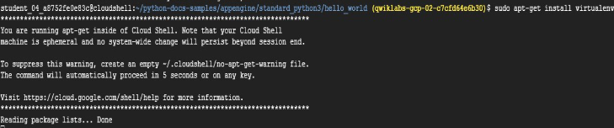

1. Now, we activate the virtual environment.



1. Then we install the dependencies by navigating the project directory.

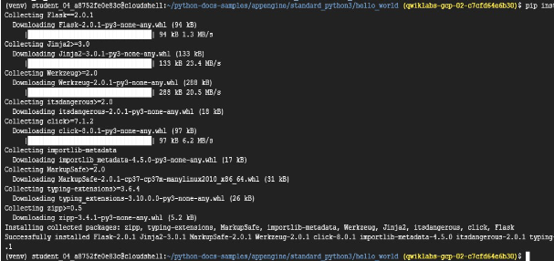

1. Now, we can run the application and get the preview.



1. Then, we deploy hello world in the app engine.

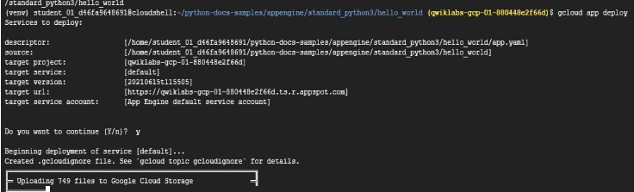

1. Now we can see deployed engine



# P6 Implement a cloud platform using open source tools.

Eucalyptus is a cloud platform that is open source. Eucalyptus, an open source technology, is what I'm talking about here. Elastic Utility Computing Architecture for Linking Your Program to Useful Systems, or Eucalyptus, is an open-source software framework that provides a platform for private cloud computing deployment on a computer cluster. Eucalyptus uses the infrastructure as a service (IaaS) concept for private and hybrid cloud solutions. Eucalyptus is a platform that allows customers to calculate resources available in private clouds as well as resources accessible externally in public cloud services through a single interface. It is built on a modular and adaptable framework for web services. Eucalyptus enables application workloads to be flexibly scaled up or down by pooling computing, storage, and network resources. API compatibility with Amazon's EC2, S3, IAM, ELB, Auto scaling cloud generation, and Cloud Watch services is provided by this program. This indicates that the hybrid cloud may have a variety of capabilities.

For the installation of the eucalyptus in the system, we have a distinct procedure. We offer both automatic and manual installation processes for the installation. I'm showcasing the system's automatic eucalyptus installation procedure. Because RHEL does not support Centos OS, we can only utilize it for the installation. The following are the stages for eucalyptus installation:

## Installing packages:

The host that is installing eucalyptus, they must have EPEL YUM repository in it. To install, we use below command.

https://lh6.googleusercontent.com/LYJGKrAA2RPsrkQsakll1d3QHI36TX7TpqXH7LehhsIAOGprhDT7d4soZM1XHsBz-MgXlfOEKg9p6Py7Q--LVGUe7sraM9KaEsdprA0JacWHylj2bOFsNGDZcsqx43aU9_0Na1Mx

we can also use eucalyptus YUM repository as follows.



## Creating of inventory:

Here ansible inventory file helps us to describe the both the hosts that will run the eucalyptus cloud and the option for the installation.

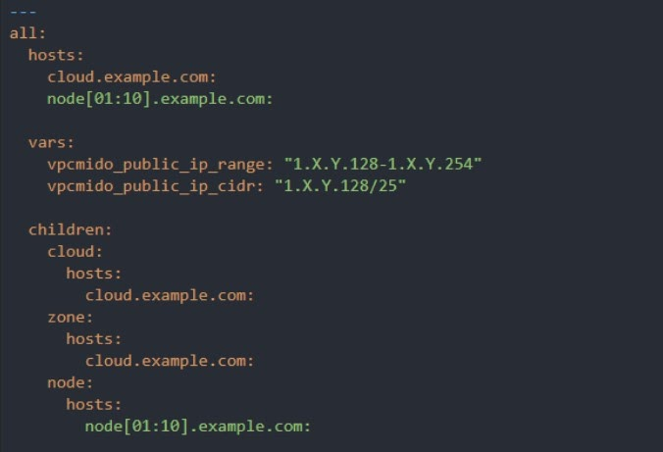

Here we can see three main section they are:

* Hosts: the host to deploy.
* Vars: variables that gives the options for the deployment.
* Children: this is the host grouping that describes where we install the eucalyptus cloud.

## Minimal installation:

For the deployment, the minimal inventory must have to specify the one host and also child cloud section which includes the host.

For the VPCMIDO the vars for vpcmido_public_ip_range and vpcmido_public_ip_cidr must also be provided.

If not, then it is assumed to be the same host as a cloud.

## Customization:

Here in the system the settings are normally in the inventory and are described in this section.

The DNS domain that we use must be set in the vars section:

https://lh3.googleusercontent.com/E7Njh4TCVbQ8wFdluM70C27wM8jf7bOkf7g15fht4Ew7dmDNUaDrKJ9eBmJvScnM34rRDPlqMfqLJByh1A-WEmt8sfYXF5WfO53QS7W2Ll5uaFu9tll67DrtAxIHJfy4yLrTwIxo

We can also use the specific ntp server

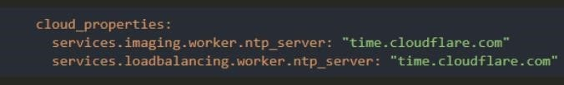

Now for the specification of the region and zone for the deployment that we need to add vars:

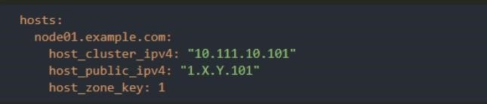

This shows us how to configure the public and cluster IP for host.

Now for the specifying of the port, we use.



Here we can see the use of port no. 443, which is the port of the we service.

Now we need to enable the firewall on the public/cluster interface.

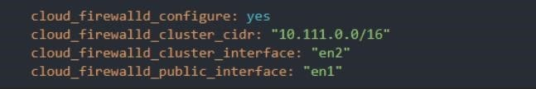

Here the interface must be named consistently on all the hosts.

The default install uses overlay for block storage, to use das we must have LVM volume group available on all storage (zone) hosts and set:

https://lh6.googleusercontent.com/qcZPujkCnxStCXznoJgsRHtol06q2Kdji0JQNdlH2FuR3ss3Cc-wmT_GYGm6WKiWELrvnNbJLqu7gfSGd6WiEp7RbuhGr6Ah51_Hiym7GayKtprVVIOYso6QuaHTQgGxCFzU54-q

To deploy the management console as a service running on an instance in our Eucalyptus cloud:

This will create the DNS entry for the console.

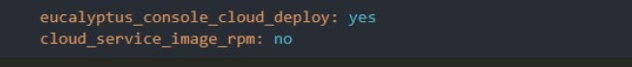

## MidoNet NSDB:

For the VPCMIDO deployments the MidoNet NSDB i.e. Network State Database must be deployed on the hosts.

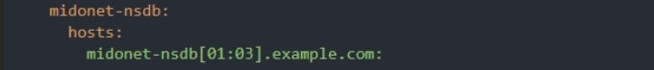

These could be the different hosts or can be lost that is running cloud and zone components.

## Use of Ceph:

For the using of Ceph for the block and also for the block storage we need to configure the settings:

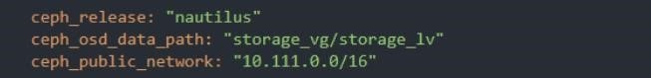

The ceph_osd_data_path should reference either an existing LVM volume available on all hosts or a device.

Here the host of the Ceph must be in the ceph group under the children.

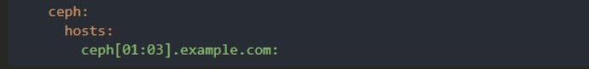

And we should know that there should be 3 or more than 3 hosts for the redundancy.

## Using MinIO:

For the deploying of the MinIO as the object storage provider we need to specify the MinIO under the children.

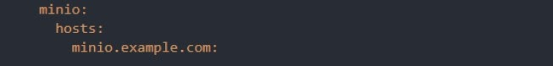

## Enabling the Certbot integration:

For the enabling of the encypt for the HTTPs via certbot we need to set the following vars:

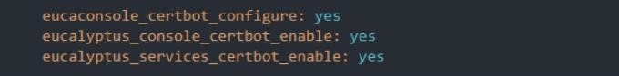

For the using of this functionality, the cloud must be the public and also reach the DNS and HTTP console.

The eucaconsole_certbot_configure_setting should be used when deploying the console on a physical host. The eucalyptus_console_certbot_enable setting applies when deploying the console on the cloud (i.e. when we specified eucalyptus_console_cloud_deploy).

## Connectivity testing:

Before the starting of the deployment, we have to test whether the installation host cloud be accessing all the host in the inventory by running it.

https://lh4.googleusercontent.com/o01-s_PtA_fn1gVlH3JLNV6m_wPxJCa1givj1M5V6uMuPrbD_J3amOrhMPo6X50lfzt1kJUARFhg5Adn0CCvLv22b-K560cP-1G5gT0J0-Nw7qv0Fx46GLhodWphmLXoGEXydaKz

If this fails then we need to ensure that we have configured the SSH access to all the inventory hosts.

## Installation performing:

For starting VPCMIDO installation, we need

https://lh4.googleusercontent.com/Rw9grmS-e9Due5rn8a7C2k1lGLOvCLVjCIXV2JK1xpKT89oTEKFvdph5VDwg3-m5SjaM8Htgw_EtlFhXH9NM0tlX0Em4RdF6BpGKII0OPt9331Farnxh7edo4R4wO9dVoY4oQCSX

Now for the EDGE installation, we need



Likewise, we can complete the installation of the Eucalyptus in the centos. This is the automated installation process in the system.

## Deploying Network Monitoring Tool: Nagios XI

Nagios XI is a free and open source computer software application that provides monitoring of all mission-critical infrastructure components including applications, services, operating systems, network protocols, system metrics and network infrastructure on a regular. It was designed to run on the Linux operating system and can monitor devices running Linux, Windows and Unix operating systems. Hundreds of third-party addons allow us to monitor internal or external application, services, and systems virtually. Nagios provides server, switch, application, and service monitoring and alerting. It notifies users when something’s go wrong and notifies them again when the problem has been resolved. For example, Nagios can monitor memory usage, disk usage, microprocessor load, the number of currently running processes and log files. Nagios can monitor services, such as Simple Mail Transfer Protocol (SMTP), Post Office Protocol 3 (POP3), Hypertext Transfer Protocol (HTTP) and other network protocols.

In a cloud system, multiple hosts or virtual machine instance must be monitored. For this purpose, we configured all the host in the Nagios XI monitoring tools. In Dashboard, in the side panel click on “Host Status” and in Host Status page, all the hosts are visible. In addition, it is the admin responsibility to ensure that every host is working well on the cloud network.

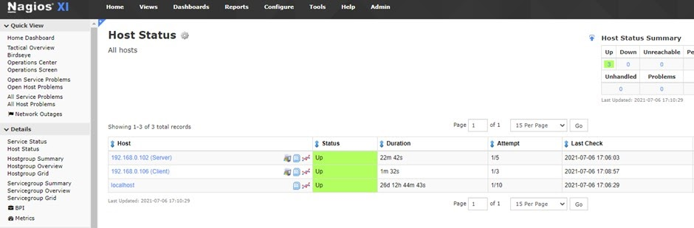

In Dashboard, in side panel we selected “Service Status” option and in “Service Status” we can see all of the services of each host. It is clear that the host and multiple services are up and running and their statuses are indicated with green, which means the service are performing normally and red indicates that the services need to be repaired or restarted. Below is the screenshot for service status.

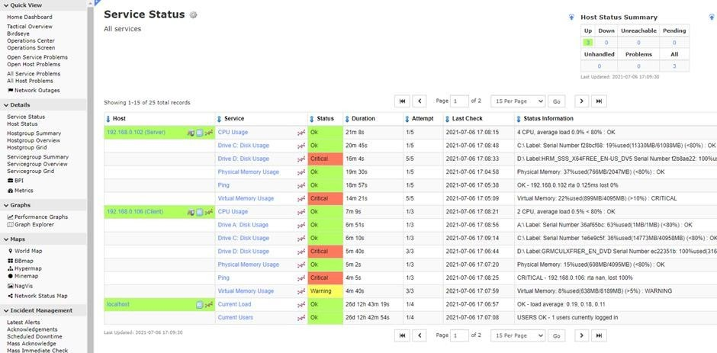

 After that, we configured the Email settings and setup alert notifications to all the host or VM instances. Now, if any host or VM instances fails to respond or disconnects in cloud network, an alert message is generated and a notification is sent to the associated staffs or users to inform them that the host is down and that they must take quick action. As soon as a host becomes unavailable, its status changes to red and shutdown as seen in the following image.

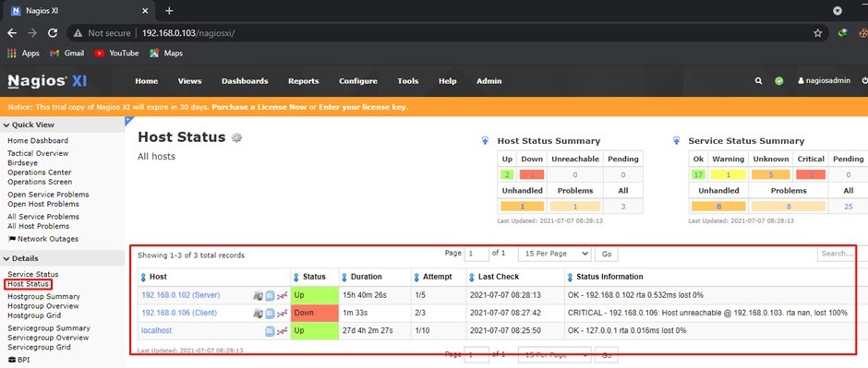

Now one of the hosts is down, and we checked the email. We confirmed that Nagios has successfully sent the notification to the email saying “PROBLEM Host Alert – 192.168.0.106 is DOWN” to the associate user.

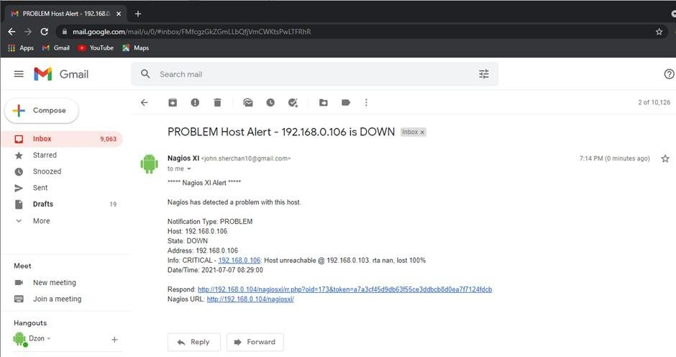

Then we fixed the problem. As soon as we fixed the problem the host in the Nagios monitoring turned Green and the email is again sent to the associated users saying “RECOVERY Host Alert -192.168.0.106 is UP” as we can see in the following image.

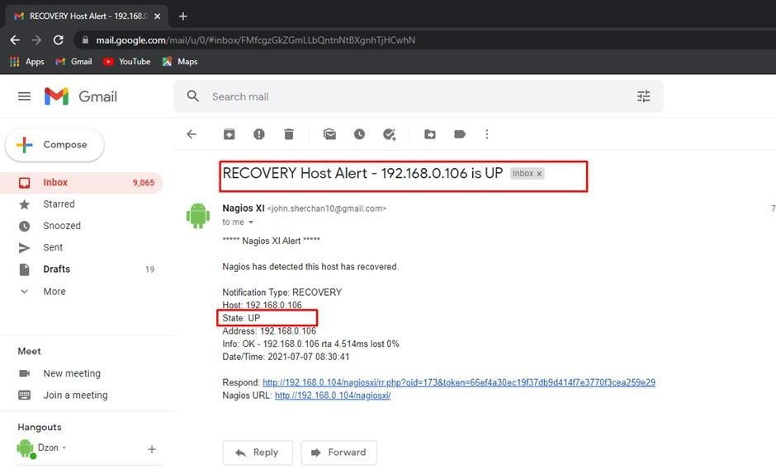

These are some of the features offered by Nagios XI and there are still various other features that can be configured to make monitoring and managing of the cloud network easy.

## Configuring AI Chatbot for customer support and review:

### Create a Dialog flow agent

 In the console on top left of navigation bar select for APIs & Services and then click on Dashboard.

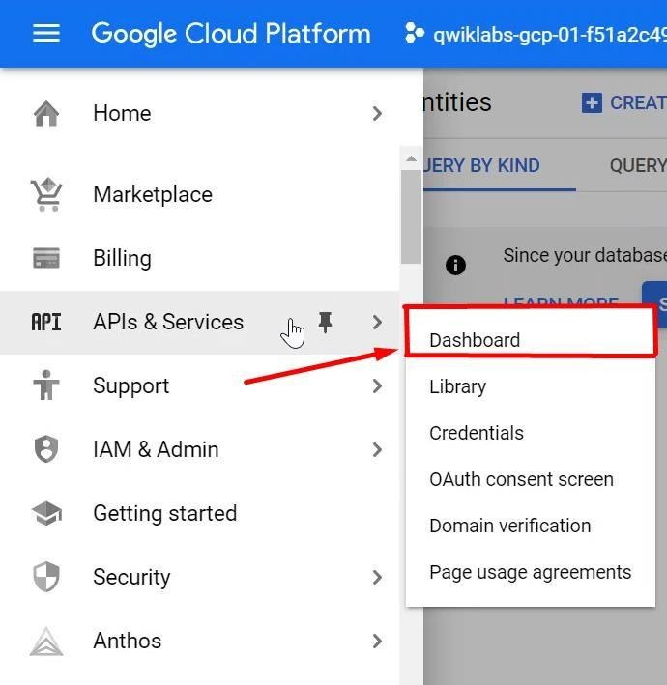

In the APIs and Services dashboard, in the top-right corner click on enable APIs and services which shows a search panel and then search for Dialogflow API.

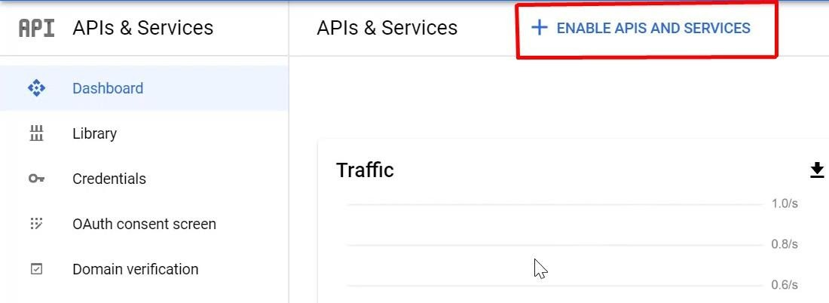

Then search for Dialogflow. After search, below result appears from API library and enable this API by clicking on the enable button.

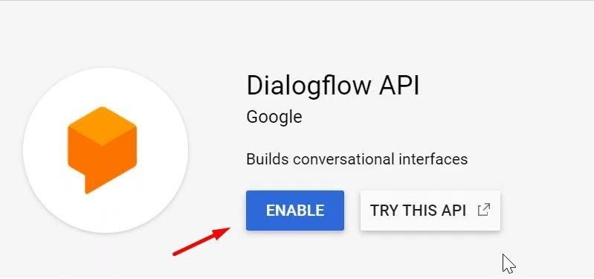

Open New Tab and go to dialogflow.com and client on go to Dialog flow Console. Then sign in with the same credentials as of GCP and click on Allow.

Then check the Terms of Service. Click on Accept.

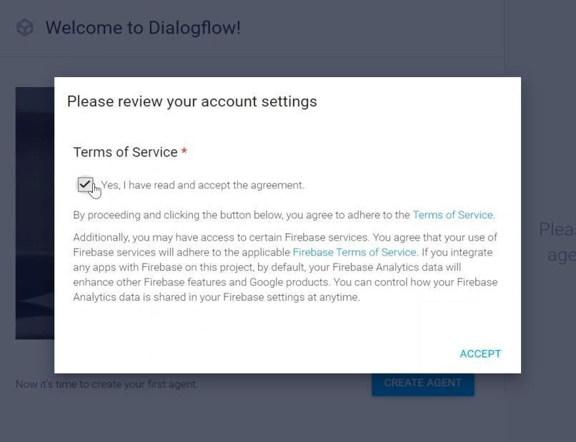

After accepting the Terms of service Home page of Dialog flow will appear. Then Click on Create Agent and add the agent information as below:

**Agent name:** Helpdesk

**Default Time zone:** America/Denver **Google Project:** GCP Project ID Then click on Create button.

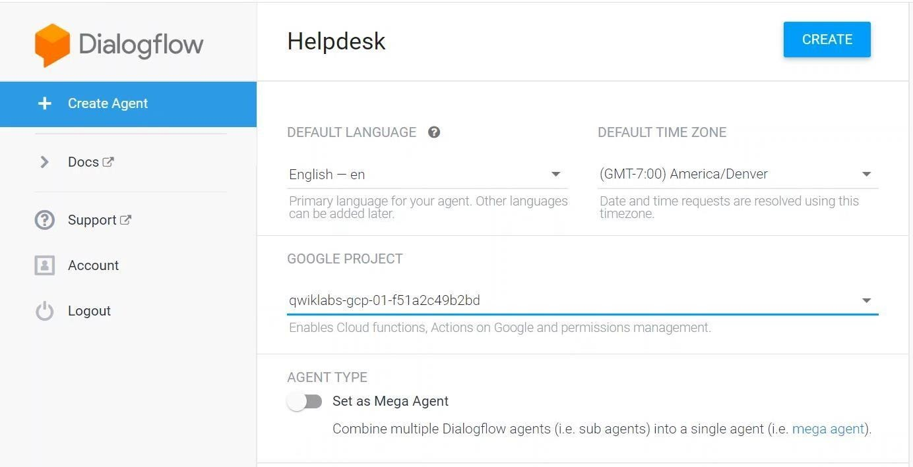

### Create Intents

After creating the agent successfully; the Default Welcome Intent is automatically created. Then Click on Intents in the left pane, then click on Create Intent: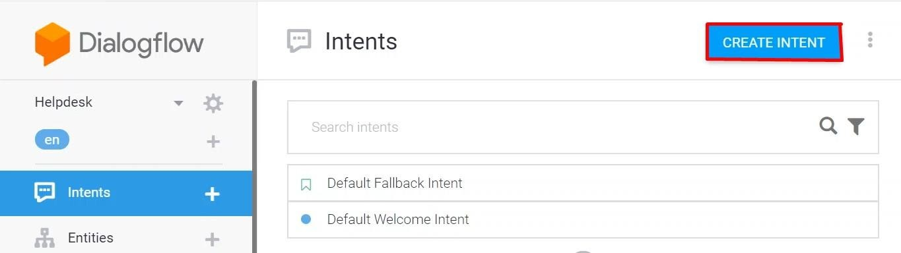

Now Name the intent "Submit Ticket".

Go to the "Training phrases" section and click on Add Training Phrases. Add the following:

* Ticket
* Submit ticket
* Problem
* Issue
* I want to submit a ticket
* I have a problem

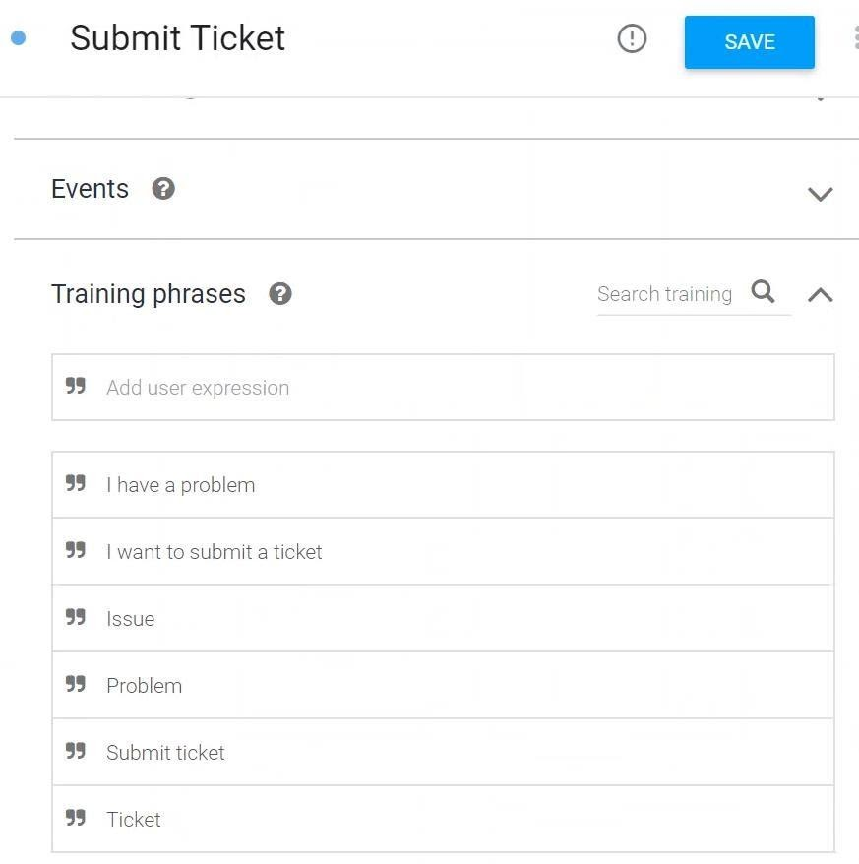

Scroll down to the "Responses" section and click on Add Response. Enter the following:

* Sure! I can help you with that. Please provide your name for the ticket. Then Click Save in the top right corner.

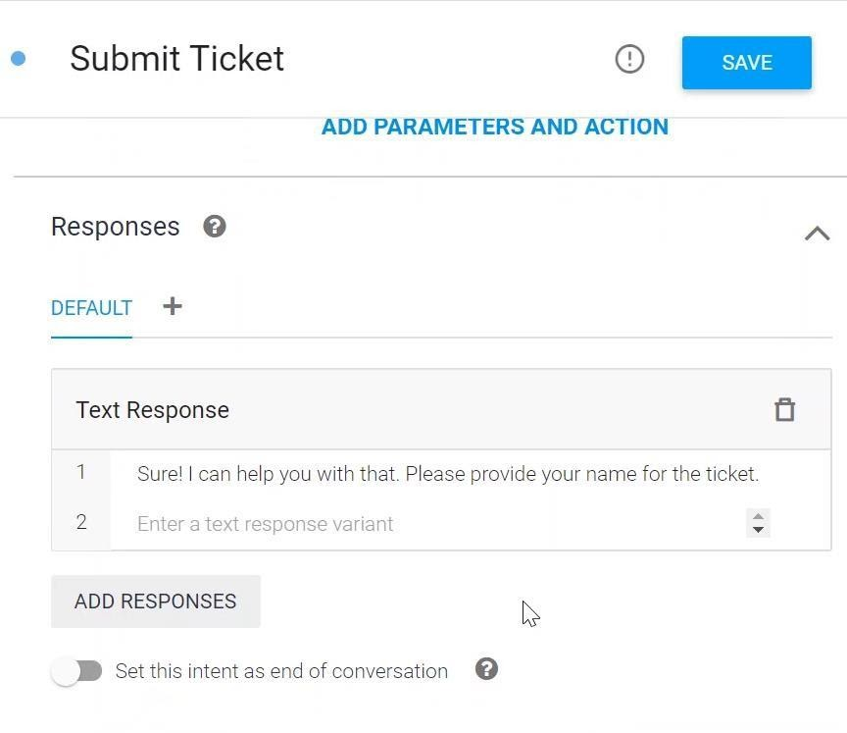

Now click on Intents in the left-hand panel, and mouse over your newly created "Submit Ticket" intent. Click "Add follow up intent" and then select custom.

Click on the new "Submit Ticket - custom" intent to edit it. Fill in the details and make sure they resemble the screenshot below:

* **Intent name:** Submit Ticket - collect name
* **Training phrases:** I am bob
* **Training phrases:** My name is Lily
* **Responses:** Thanks $person! Now describe your issue.

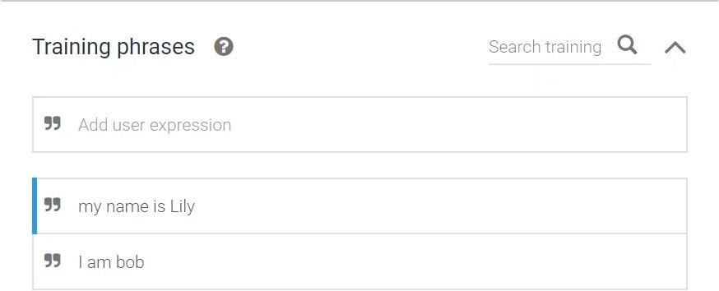  
  
  
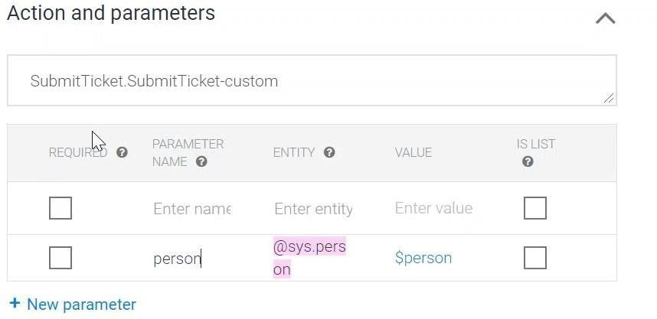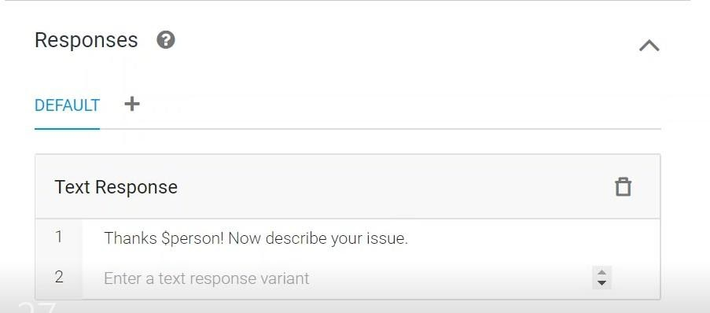

As we add training phrases, when we type "My name is Lily" a default entity is created called person (if it doesn't appear by default, please select @sys.person for Lily and bob manually). In the Text response section, a $ is added before person to represent a variable. This will let the Chatbot echo the user's name back to them.

Then Click Save when done.

### Allow Fulfillment to Store Help Ticket Data

As Dialog flow automatically added a context of SubmitTicket-followup where we have to enable Inline Editor for the intent in the Fulfillment tab and some error may be seen which can be ignored.

In the Inline Editor, copy the index.js code as give and replace the project ID in line 6. The result should look something like this:

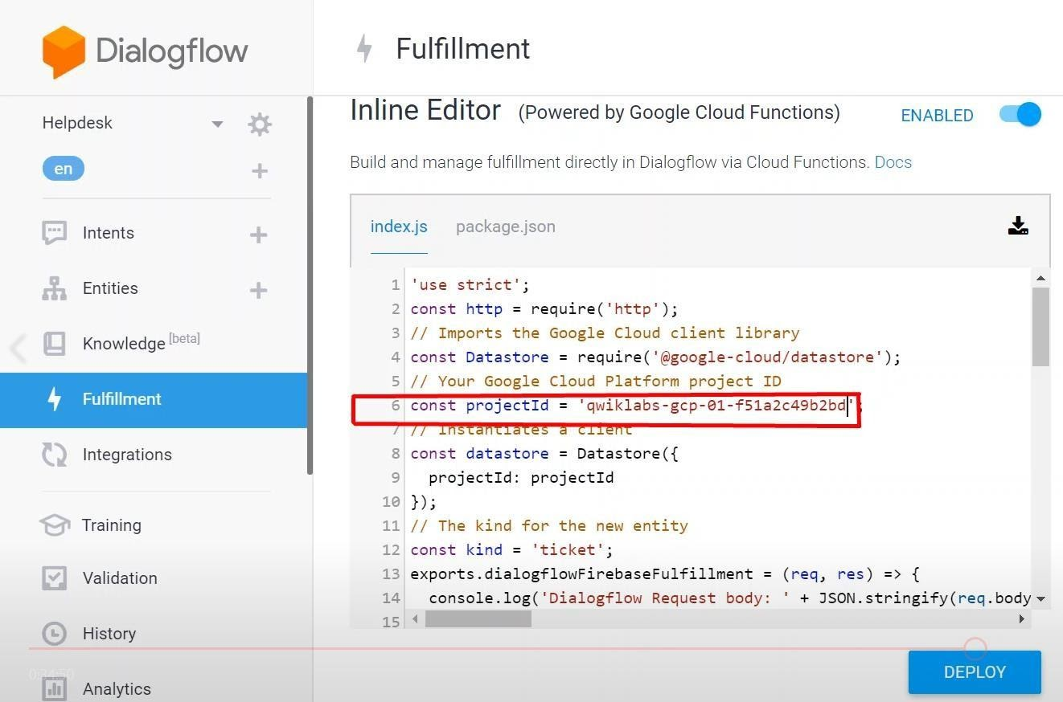

Then click on the package.json tab add this dependency:

"@google-cloud/datastore": "^1.1.0"

Remember to add a comma after the last item in the dependency list. The result should look something like this:

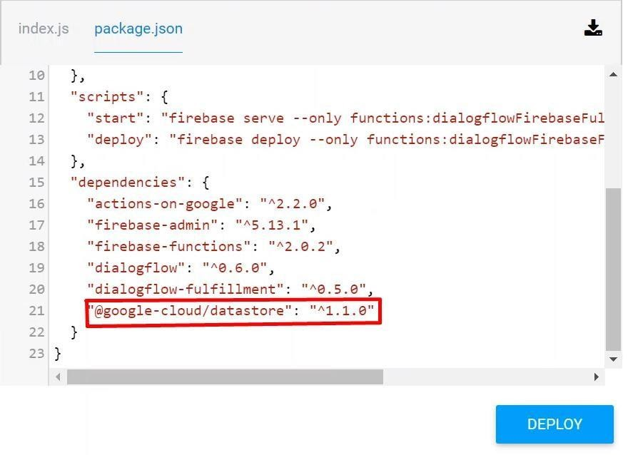

Then click the Deploy button. Wait until the message of deployment was successful (this might take a little while).

Next, go back to Intents in the left panel. Click the down arrow next to "Submit Ticket" to reveal its follow-up intents.

Mouse over "Submit Ticket - collect name" and click "Add follow up intent", then select Custom.

Click on the newly created intent "Submit Ticket - collect name - custom" to open it for editing.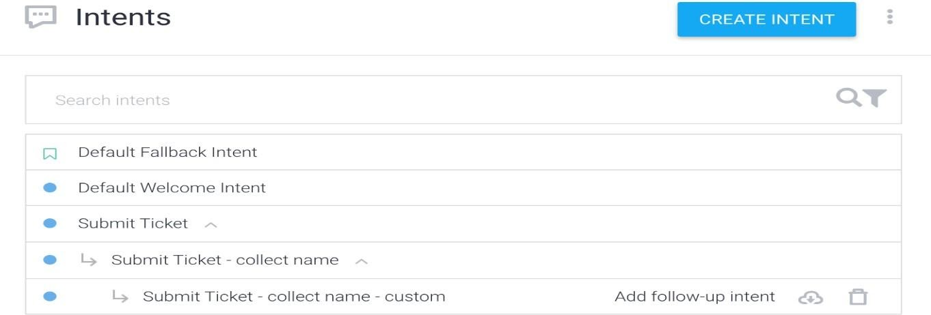

Name the intent "Submit Ticket - collect description".

Enter some user expressions into Training phrases as shown below. Here is what we selected for Training phrases:

* Everything is hosed
* My laptop won't start
* Nothing works
* My phone screen is broken

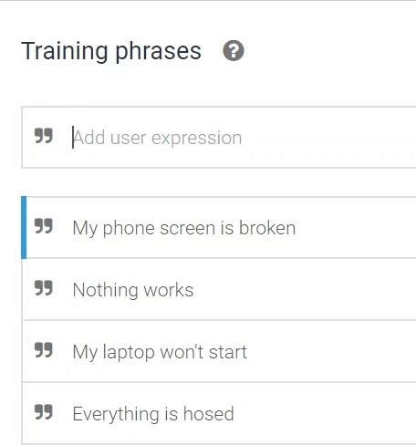

Scroll to the bottom of the screen click on the Fulfillment arrow to toggle the section. Click on Enable web hook call for this intent and click on Save button.

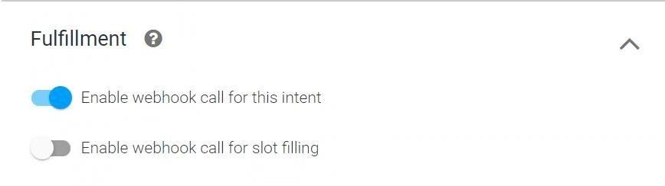

At this point, the Dialogflow should be set up and the intent are also working correctly as can be seen in below screenshot.

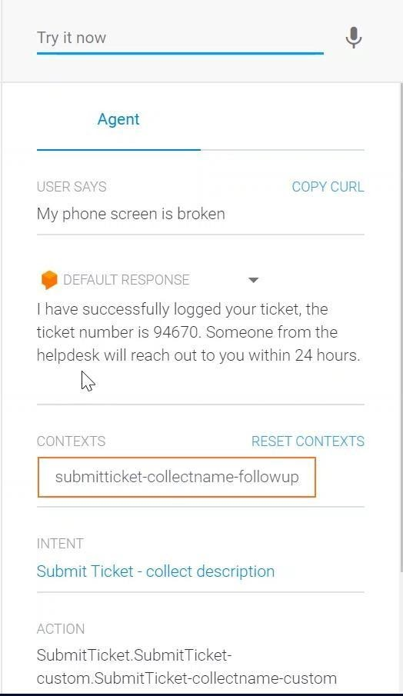

### Verify that Tickets Are Logged in Data store.

In order to verify that, we have to go to google cloud solution and then go to Data store from left navigation pane. As we can see here, the query is listed and tickets are successfully logged in Data store.

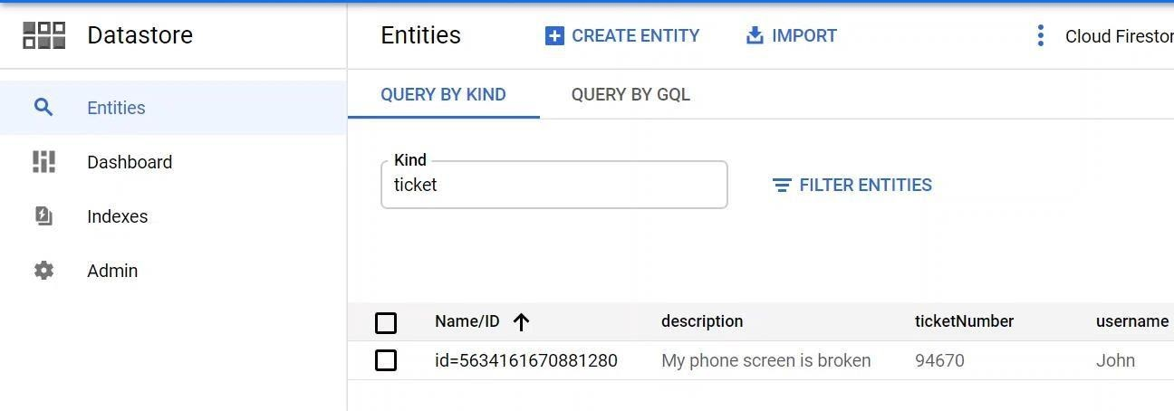

This shows that we successfully implemented AI Chabot’s for customer support.

# Conclusion

In this part, I was able to learn about a variety of public and open source cloud computing solutions. I've configured the Google cloud platform in this case. Similarly, I may learn about Eucalyptus, which is utilized in the bank's private cloud.

# Part3

**A. Write an article which**

* **Analyzes the most common challenges and risks which arise in a Cloud Computing platform and discusses appropriate solutions to these problems. How does Cloud computing help to reduce the time to market for applications and to cut down capital expenses?**
* **Assesses the most common security issues in cloud environments**

# ARTICLE

# Common Challenges and security issues in Cloud Computing and their solution

**Bisesh Shrestha**

**Introduction**

The way businesses build, manage, and maintain their applications and infrastructure has changed tremendously thanks to cloud computing. Developers now have simple access to a large selection of cloud services, as well as great freedom in how each service may be configured, allowing them to construct complex, contemporary programs rapidly. This freedom to innovate, however, comes with its own set of cloud security concerns to consider. As a result of the cloud's dynamic nature, information security teams are being compelled to rethink their processes in order to manage new security and compliance challenges. In this article, we'll go over some of the most typical obstacles that cloud deployment professionals face, as well as some suggestions on how to solve them. We'll also talk about the security risks that come with cloud computing and how to deal with them. Finally, we'll go through how a business may safeguard its data while migrating to a cloud solution.

# P7: Analyse the most common problems which arise in a Cloud Computing platform and discuss appropriate solutions to these problems.

**Problems that can occur in a cloud computing environment, as well as solutions**:

The following are some of the various issues that emerge with cloud computing, as well as mitigation measures:

**Data security concerns**: A range of severe dangers, such as virus assaults and hacking of client websites, are the most important cloud computing data security concerns. Before integrating cloud computing technology in their business, entrepreneurs must examine the following aspects. Several topics remain unanswered when it comes to discussing the security vulnerabilities related with cloud computing.

**Lack of skills**: Prime Bank lacks the necessary competence to implement cloud-based technology. They lack the essential skills and resources to properly employ cloud computing technologies. Implementing and choosing the right cloud might be tough without the right help. Educating Prime Bank personnel about the cloud computing process and technologies is a huge task in and of itself. Putting pressure on a corporation to migrate to cloud-based technology without a thorough grasp of the technology is a recipe for catastrophe.

**Costs of cloud computing**: Especially for small and medium-sized enterprises, costing is a key problem in the adoption, migration, and operation of cloud computing services. However, because cloud computing services are scalable and on-demand, it might be difficult to properly define and anticipate quantities and prices. On a small scale and for short-term endeavors, cloud solutions may look excessively costly. The most major cloud computing advantage, on the other hand, is the decrease in IT costs. Pay-as-you-go cloud services can provide you greater flexibility and save you money on hardware.

**Cloud integration**: Many enterprises, particularly those who operates in a hybrid cloud context. They can have problems connecting their on-premises applications and resources to the public cloud environment.

**Cloud migration:** It refers to the process of migrating all apps and data from on-premise storage to the cloud. It can be difficult to move corporate activities to a different cloud service provider, and it can have an impact on the operation of other systems.

**Managing a Multi-Cloud Environment**: Instead of using a single cloud, enterprises are now leveraging numerous public and private clouds. Managing a multi-cloud setup can be challenging at times. Using a multi-cloud setup introduces a slew of new complications and issues for IT teams to contend with.

**Business continuity and service availability**: One of the constraints or challenges with cloud computing is that it is impossible to deliver the service as described in the SLA at all times since there may be a problem with the device or another system. What happens if the service provider is unable to supply the requisite number of services to the client at that time? Furthermore, if the service provider went out of business, the consumer would be served at an inconvenient time. Working in the cloud, as a result, may become a concern in the future. We may receive services from a variety of cloud vendors to help us deal with this problem. We can acquire service from another service provider if one goes down if we get services from numerous service providers.

**Data confidentiality and auditability**: An organization's data and information might be enormous. If the company stores sensitive data on the cloud, there might be catastrophic consequences. Because there is a risk of the cloud misusing the data, there may be trust difficulties. As a result, storing personal data in the cloud is risky. So, before using the cloud, a security and legal audit is required, and after the audit, we must determine if they have met the compliance requirements or not. One of the most crucial aspects to consider in cloud computing is security.

**Data lock-in**: Cloud storage, as we all know, is fundamentally proprietary, meaning that data saved in one cloud cannot be accessed by any other cloud. The data cannot be extracted into various clouds by SaaS developers. The data is locked in one cloud and cannot be transferred to another.

**The mitigating measure for this issue is that we can use standardization of the data API’s**.

Performance unpredictability: Virtual machines are employed on the cloud, and they share CPUs and main memory. Input/output sharing via the network and on storage has therefore become less predictable. As a consequence, we may deduce that the performance given is unpredictable due to the fact that they share resources like CPU and memory. To mitigate this issue, we can use flash memory which preserves the information even when it is powered off like a hard disk and it is much faster to access. This reduce the input and output interference.

**Solution to overcome these challenges:**

Appropriate solution to above mentioned challenges is described below:

**Preventing Data Security Issues**: Addressing the concerns about data privacy and cloud security that have been raised is crucial. By monitoring user access control and restricting access to certain individuals, several measures may be introduced to improve data security. Only authorized users will have access to certain cloud data that is necessary to carry out specific business processes. Prime bank, on the other hand, should encrypt important data to reduce the effect of cloud data breaches and other assaults.

**Staff and team training**: It's critical that everyone at Prime Bank has the necessary skills, knowledge, and understanding to run the new infrastructure. Customers may attend team training sessions as well as watch video lectures provided by cloud service providers. Furthermore, creating an incremental adoption strategy might assist to relieve some of the burden that comes with locating and qualifying competent people.

**Cloud costs**: There are several ways to manage and control cloud costs. Organizations may save money on cloud computing by automating governance controls, improving financial analytics and reporting, and maintaining an uniform management reporting strategy, for example. Another strategy to address the cloud cost difficulty is to plan a cost estimate budget from the start.

***Cloud migration and managing multi- cloud environment***: Pre-migration testing is the best way to overcome the cloud migration challenges that come with cloud migration. To assess the situation better, make sure to stick to the budget and project deadlines during the testing phase.

One of the most effective ways to overcome managing multi-cloud environment challenge is to use appropriate tools such as cloud cost, management solutions, automation, auto-scaling features and other tools which help in the management of a multi-cloud environment

# P8:Assess the most common security issues in cloud environments.

## Common security issues in cloud computing platform:

**Misconfiguration**: Cloud infrastructure misconfiguration is a common source of data breaches. Critical corporate data and applications may become exposed to an attack if an organization's cloud infrastructure is not setup appropriately. It might be challenging for an organization to guarantee that only authorized individuals have access to their data because cloud infrastructure is meant to be freely available and promote data sharing. In summary, misconfiguration may lead to major cloud security risks for enterprises, with the subsequent repercussions wreaking havoc on day-to-day operations.

**Unauthorized access**: The ability to offer features on-demand through self-service capabilities increases the productivity of PaaS and SaaS implementations. It does, however, raise the possibility of illegal access. Organizations are particularly vulnerable when services and features are utilized without IT competence. Employees can access remotely hosted data via remote computing devices such as laptops, mobile phones, and tablets, posing cloud computing security risks for businesses, particularly if employee carelessness and credential misuse are involved.

**Insecure APIs and interfaces**: Insecure API and interfaces can contribute to cloud computing security issues. APIs are necessary for a tailored cloud experience, but they also pose a significant security risk. APIs enable businesses to tailor the cloud solution's features to meet their own needs. Encryption, access, and data recognition are also included. Interfaces that are poorly designed are more likely to be abused, resulting in data breaches. While APIs are valuable to developers, they might pose security issues if not rigorously checked for bad design and security.

**Insider threat**: Cyberattacks aren't limited to external threats; insider threats are also a major problem for businesses. While this is a problem in on-premises setups, it surely poses security and risk difficulties with cloud computing. Detecting suspicious behavior connected to malevolent insiders might be much more challenging due to the cloud's architecture and the fact that the infrastructure is accessible over the public internet.

**Reduced visibility and control**: When an organization migrates to a cloud-based computing paradigm, part of the responsibility for policies and infrastructure is shifted to the cloud provider, resulting in a loss of visibility and control. The size of the duty changes will be decided by the cloud service model utilized. The lack of visibility and control that comes with SaaS, PaaS, and IaaS may cause a slew of cloud computing security challenges for businesses.

**Conclusion**

Cloud computing is a versatile, cost-effective, and well-proven delivery platform for IT services delivered through the internet. However, because vital services are commonly outsourced to a third party, cloud computing presents a new level of risk, making it more difficult to manage data security and privacy, assure data and service availability, and verify compliance. We looked at some of the most typical concerns that might develop in the cloud computing platform, as well as possible remedies, in this post.

# Presentation slide on the topic given to me:

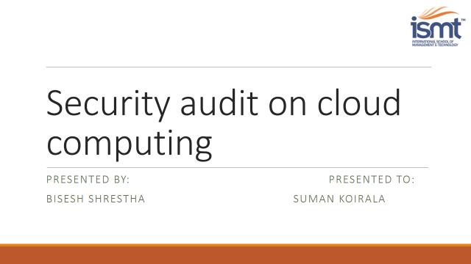

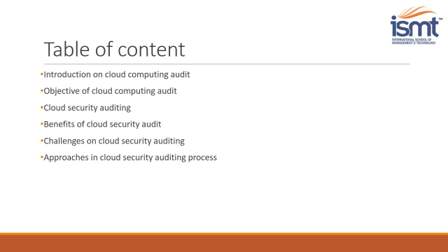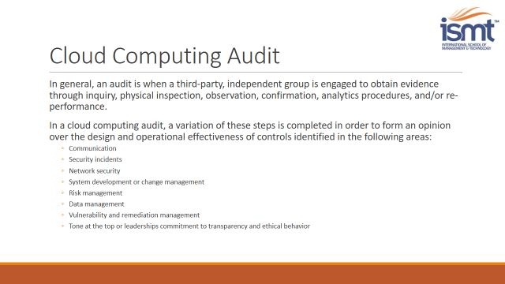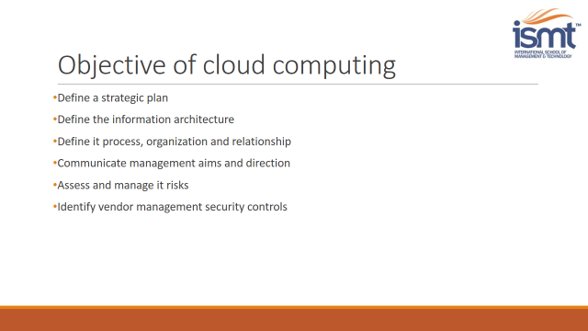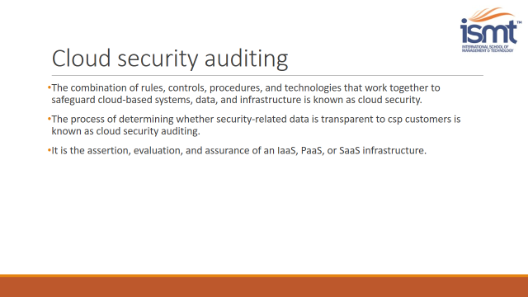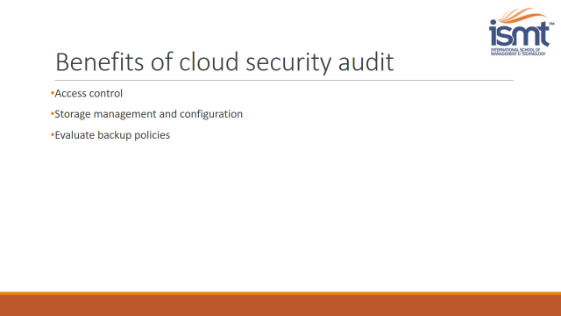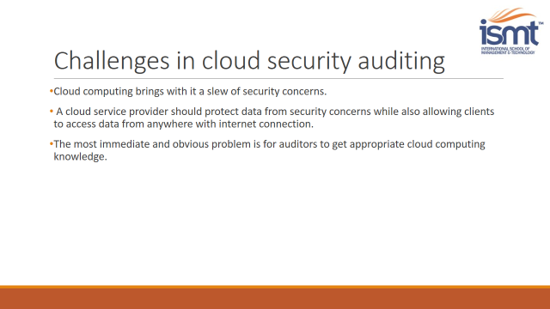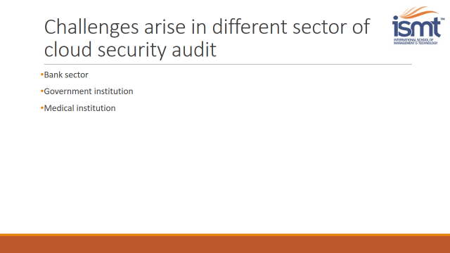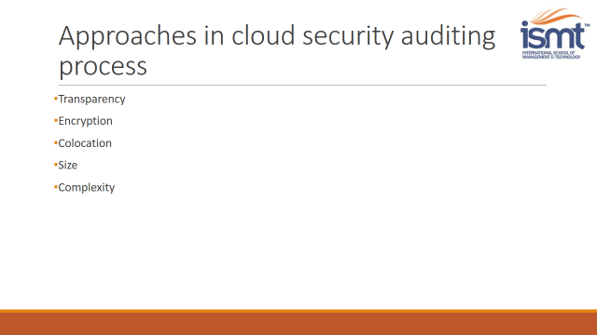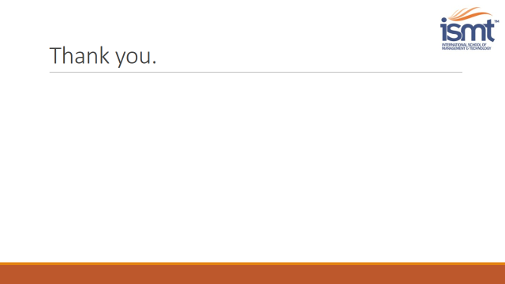

# References

<https://azure.microsoft.com/en-us/overview/what-is-cloud-computing/#cloud-deployment-types>

<https://azure.microsoft.com/en-us/overview/what-is-cloud-computing/#cloud-computing-models>

<https://www.javatpoint.com/cloud-computing-architecture>

<https://www.geeksforgeeks.org/history-of-cloud-computing/>

<https://www.investopedia.com/terms/c/cloud-computing.asp>

<https://www.businesstechweekly.com/cybersecurity/data-security/cloud-computing-security-issues-and-challenges/>

[https://www.leadingedgetech.co.uk/it- services/it-consultancy-services/cloud-computing/what-are-the-types-of-cloud- computing/](https://www.leadingedgetech.co.uk/it-%20services/it-consultancy-services/cloud-computing/what-are-the-types-of-cloud-%20computing/)

[https://www.leadingedgetech.co.uk/it- services/it-consultancy-services/cloud-computing/what-are-the-types-of-cloud- computing/](https://www.leadingedgetech.co.uk/it-%20services/it-consultancy-services/cloud-computing/what-are-the-types-of-cloud-%20computing/)

[https://www.acronis.com/en-eu/articles/google-cloud- platform/](https://www.acronis.com/en-eu/articles/google-cloud-%20platform/)

[https://www.globaldots.com/resources/blog/how-to-overcome-five- common-cloud-challenges/](https://www.globaldots.com/resources/blog/how-to-overcome-five-%20common-cloud-challenges/)

<https://www.g2.com/articles/cloud-computing#what-is-the-cloud>

<https://www.geeksforgeeks.org/evolution-of-cloud-computing/>

<https://en.wikipedia.org/wiki/Eucalyptus_(software)>

[https://www.controleng.com/articles/five-characteristics- of-cloud-computing/](https://www.controleng.com/articles/five-characteristics-%20of-cloud-computing/)